

FP6-511931

Mind RACES

From Reactive to Anticipatory Cognitive Embodied Systems

DELIVERABLE D12 (D6.2)

Implementation of Preliminary Integrated Architectures and Preliminary Tests

Due date of deliverable:
30 / 09 / 2006

Actual submission date:
25/10/2006

Start date of project: Duration:
01 / 10 / 2004 36 month

Organization name of lead contractor for this deliverable Revision:
IDSIA 04

Project co-funded by the European Commission within the Sixth Framework Programme (2002-2006)
Dissemination Level
PU | Public
PP | Restricted to other programs participants (including the Commission Services)
RE | Restricted to a group specified by the consortium (including the Commission Services)
CO | Confidential, only for members of the consortium (including the Commission Services) | X

Document identifier: | DEL_6.2
Date: | 25/10/2006
Work package: | WP6
Partner(s): | IDSIA, ISTC-CNR, IST, LUCS, NBU, NOZE, OFAI, UW-COGSCI
Lead Partner: | IDSIA
Document status: | approved
Deliverable identifier: | WP6_DEL6.2.doc

Delivery Slip
 | Name |  | Partner | Date | Signature
From | Alexander Förster |  | IDSIA | 16/10/2006
Verified | Luca Tummolini |  | ISTC-CNR | 24/10/2006
Approved by | Rino Falcone |  | ISTC CNR | 25/10/2006

Files
Software Products |  | User files
MS Word™ |  | 0000.doc

Project information
Project acronym: | Mind Races
Project full title: | MIND RACES: from Reactive to Anticipatory  Cognitive Embodied Systems
Proposal/Contract no.: | IST-511931
Project Manager: | ISTC_CNR
Name: | Rino Falcone
Address: | CNR-ISTC via S. Martino della Battaglia,44 00185 Rome ITALY
Phone: | +39 06 44 595 253
Fax: | +39 06 44 595 243
E-mail | rino.falcone@istc.cnr.it

Table of Contents
Summary of partner cooperation 7
Part I - Integration 10
ISTC-CNR and LUCS: Integrating Action and Attention in a Robotic Eye-Arm System 11
NBU and LUCS: Integrating AMBR and IKAROS 35
ISTC-CNR and IST: Integrating Emotions into Anticipation Behaviors 50
UW-COGSCI and IDSIA: Joint Hierarchical Neural Network Development 78
ISTC-CNR and NOZE: Theoretical Model Development and Design Solutions. 82
Part II - Methods and Software Transfer 86
OFAI and IDSIA: Using Long Short-Term Memory 87
IDSIA and LUCS: From Bouncing Ball Simulation to Marble Run Game Scenario Environment 89
NOZE and LUCS: Technological integration between AKIRA and IKAROS 91
Part III - Comparisons 92
ISTC-CNR and UW-COGSCI: Comparing two models of goal oriented actions 93
OFAI and IST: Emotive driven Artificial Immune System 95
UW-COGSCI and OFAI: Comparing Artificial Immune Networks and Learning Classifier Systems 99
OFAI and ISTC-CNR: Comparing Artificial Immune Networks and Fuzzy-Based Schema Mechanisms 102
UW-COGSCI and ISTC-CNR: Comparing Robot Arm Models 106

Summary

This document describes the progress of the integration task (work package 6) in the MindRACES project. It gathers information from MindRACES partners related to their collaboration on different working areas inside the MindRACES project.
The current cooperation state has evolved from previous considerations described in the first deliverable D9 (D6.1) of this work package as well as from presentations and discussions on previous project meetings. Most integration processes are currently in progress. The final deliverable D19 (D6.3) of this work package will report the results of this development.
Introduction

Various cooperation methods between the project participants reflect the different characteristics of the integration processes. In this deliverable the integration effort has been organized along three different lines:
- Joint system integration between at least two models or achitectures
- Transfer of technology and methods from one partner to the others
- Comparisons between different models

Deliverable D9 (D6.1) gives an overview of the status and descriptions of the work of all partners, providing the basis for current cooperation and integration, presented in this document. Prototypes can be found on the MindRACES homepage.

Cognitive mechanisms include predictive, anticipatory and general cognitive mechanisms. The goal of integrating cognitive mechanisms is to provide better performance of the overall model, compared to using a single mechanism. Different combinations of mechanisms are possible, e.g. general and predictive mechanisms or predictive and anticipative mechanisms.

An important part of the cooperative effort is to compare different architectures for the same cognitive processes. The advantages, disadvantages and limits of the particular architectures can be easily identified and this knowledge can be used to improve the systems.

Continuous work has also shown that the integration of different frameworks and code sharing as well as research visits and intellectual cooperation increase the scientific progress substantially.

In what follows, first a summary of all the ongoing integration activities is provided and then each of the activity is described in detail.

Summary of partner cooperation

ISTC-CNR
NBU
LUCS
IDSIA
OFAI
IST
UW COGSCI
NOZE
Methods and Software Transfer from
Comparison
Integration

Fig.1. Summary of partner cooperation.

INTEGRATION

ISTC-CNR and LUCS
ISTC-CNR and LUCS are integrating low-level action based (ISTC-CNR) and high-level attention based (LUCS) cognitive architectures. They use a simulated as well as a real robotic arm. The arm was assembled by ISTC-CNR. They developed some low-level behaviors for the arm. The high level cognitive mechanisms are based mainly on LUCS’ IKAROS framework.

NBU and LUCS
NBU and LUCS are cooperating for building an integrated architecture for real-world robot problem solving. They have integrated the AMBR system developed by NBU with the IKAROS system developed by LUCS and implemented them into a single AIBO robot platform.

ISTC-CNR and IST
The joint work between ISTC-CNR and IST aims to improve and integrate the ISTC-CNR agent architecture with some of the anticipatory and emotional components prepared by IST researchers.

UW-COGSCI and IDSIA
UW-COGSCI and IDSIA are working on a hierarchical neural network implementation. The resulting system will be applied to the tracking tasks, proposed by LUCS and others in the MindRACES project.

ISTC-CNR and NOZE
ISTC-CNR and NOZE have developed, implemented and tested many theoretical models. This implies high level cognitive functionalities (e.g. planning) as well as low level behaviours (e.g. action selection) and interaction between these layers. Their strict collaboration was focused on the development and refinement of the AKIRA open source framework. While NOZE continued to support the technological development of new modules in the AKIRA cognitive architecture, ISTC-CNR continued to collaborate with NOZE for the design of the cognitive features and characteristic needed in ISTC-CNR research and to develop agent models based on AKIRA.

METHODS AND SOFTWARE TRANSFER

OFAI and IDSIA
OFAI has investigated different LSTM implementations and have chosen the IDSIA one for their future work in the third year of the MindRACES project. OFAI will use it for simulating delayed effects in their Artificial Immune System (AIS).

IDSIA and LUCS
LUCS has developed some environment scenarios, which will be used by IDSIA to apply their predictive cognitive mechanisms in combination with the IDSIA fovea model. The usage of IDSIA models will enable better predictive performance in the given scenarios.
NOZE and LUCS
NOZE was able to integrate a powerful peer-to-peer communication mechanisms into IKAROS. Now both systems are able to send/receive between them data of any kind also delegating function calls (i.e. daemons in AKIRA, modules in IKAROS) to each others.

COMPARISON

ISTC-CNR and UW-COGSCI
ISTC-CNR and UW-COGSCI have compared and investigated the implications of the ideomotor principle (IMP) and the test operate test exit control loop (TOTE) for adaptive behavior and action selection.

OFAI and IST
OFAI and IST are currently collaborating in finding sub-symbolic mechanisms that generate emotive states influecing the behaviour of the OFAI Artificial Immune System (AIS), and enabling more complex anticipatory behaviours.

UW-COGSCI and OFAI
UW-COGSCI and OFAI are working on a comparison and integration of their two systems, the Artificial Immune System, and artificial immune networks in particular, and Learning Classifier Systems, and the XCS classifier system in particular.

OFAI and ISTC-CNR
OFAI and ISTC are working on a comparison and integration of their two systems, the Artificial Immune System, and Artificial Immune Networks in particular, and the fuzzy-based Schema Mechanisms used in the ISTC AKIRA Architecture.

UW-COGSCI and ISTC-CNR
ISTC-CNR and UW-COGSCI have developed two robot arm models. Both models realize anticipatory principles in their own way. The ISTC-CNR system is mainly formed by two components: a postural controller and a reinforcement-learning component. UW-COGSCI’s controller focuses on learning an actual servoing mechanism by means of ideomotor principle. UW-COGSCI and ISTC-CNR plan to write a comparison of the two approaches and combine them into one goal-oriented architecture that can avoid obstacles flexibly and adaptively reach constrained goal positions.

Part I - Integration

ISTC-CNR and LUCS: Integrating Action and Attention in a Robotic Eye-Arm System

Motivation
A challenge of MindRACES is to build at least one integrated architecture validated on a real robotic system. ISTC-CNR is responsible for one of the two attempts of fulfilling this goal promised in the project (the other being under the responsibility of IDSIA). With this respect, ISTC-CNR plans to integrate two models developed within the project:
- ISTC-CNR’s models developed for controlling robotic-arms within the WP4 “Goal directed behaviour” (Ognibene et al., 2006; Ogbibene et al., 2006b).
- LUCS’ models developed for attention control within WP3 “Attention, monitoring and control” (Balkenius et al., 2004; Balkenius and Johansson, 2005; Balkenius and Johansson, 2006).

The scientific relevance of this integration resides in these circumstances:
- The models of ISTC-CNR focus on control and tackle the following anticipatory functionalities:
  - Internal representations of goals as anticipated states that govern the behavior of the system (the activation of these representations lead the system to act in the world in order to increase the probability that they will be accomplished: cf. Pezzulo et al., 2006).
  - Selection of future goals on the basis of a winner-take-all dynamic competition between goals which integrates information in time and is anticipatory with respect to future overt behavior.
  - Reinforcement learning capability based on the anticipation of future discounted rewards.
- The models of LUCS focus on attention and tackle the following anticipatory issues:
  - General purpose pre-attentive mechanisms that focus attention on locations where the information gain might be high.
  - Top-down, task related anticipation of locations with high information gain based on reinforcement learning algorithms.
So far LUCS’s (top-down) attention mechanisms have been trained to focus on particular pre-specified targets. An important challenge of the integration is to verify if it is possible to exploit a unique “critic” trained on the basis of a unique final reward signal, produced by the arm’s overt behavior, to train synchronously both the “actor” controlling the attention focus (the eye) and the “actor” controlling movements (the arm; see below for the concepts of “critic” and “actor”).
Another important challenge of the integrated architecture is to evaluate if it can furnish a better account of the empirical data collected with monkeys tested with the same task as the one that will be used to test the architecture itself (see below).

The remaining sub-sections will illustrate:
- The task that will be used to test the integrated architecture
- The simulated system and the robotic systems that will be used to test the architecture
- The integrated architecture
- Some preliminary results directed to test the architecture components dedicated to control the “arm” of the system.
- Some preliminary results directed to test the architecture components dedicated to control the “eye” of the system.

The task
The architecture presented here will be tested using the “discrimination reaching task” used by Cisek & Kalaska (2005) to carry out physiological recordings in monkeys’ premotor cortex. The task is composed of five phases (see Figure 1):
- center-hold time: the monkey’s hand is positioned on a manipolandum at a central starting position of an horizontal plane, and a green cue circle appears at the center of a screen set in front of the subject;
- spatial cue: a red and a blue circle (with a 2 cm radius) appear on the screen at two opposite positions of eight possible target locations distributed around a circle;
- memory: a green cue circle appears again at the center of the screen;
- color cue: a color cue, either red or blue, appears at the center of the screen: this non-spatial cue signals which of the two memorized color-coded spatial cue locations is the target that the monkey should reach;
- go signal: eight green circles appear at all the possible target locations: if the monkey reaches the target position that matches both one of the two spatial cues and the color cue, it receives a reward.

In the simulations, the first four phases last 1 s. each, while the fifth phase lasts 16 s before a time out takes place.

The task has a number of advantages with respect to testing the integrated architecture proposed here:
- The experiment has already been tackled with success by ISTC-CNR with an bio-inspired neural architecture (Ognibene et al., 2006).
- The task has been taken from a neuroscience paper (Cisek & Kalaska, 2005) that describes interesting data, physiological and behavioral, related to monkeys engaged with the task: these data can be compared with the results obtained with the computational architecture proposed here.
- The empirical behavioral data reported in such paper refer to both arm control and eye control: for this reason they represent an ideal test for the integrated architecture proposed here AS IT intends to integrate anticipatory mechanisms operating at the level of arm’s motor control (ISTC-CNR) and visual attention (LUCS).
- Some of such data relate to interesting anticipatory processes underlie the monkeys’ behavior, for example (see Cisek & Kalaska, 2005, for details): (a) after training, the monkeys move the eye to the arms’ targets before the arm reaches them, or to locations where relevant cues will appear; (b) the activations of pre-motor cortex neurons underlying the arm’s movements activate in correspondence to candidate or selected arm’s targets before the actions are executed.
- The task is computationally complex and challenging as it gives rise to a set of “x-or” sub-problems.
- The task involves the processing of a sequence of images and hence requires integration of information in time (e.g. through memory and attention)
- The task allows simplifying the hard (and out of scope) problem of object’s recognition as targets and cues have distinct colors.

Legend: Green: Blue: Red:
Phase 1 Phase 2 Phase 3 Phase 4 Phase 5
Time
Fig 1. The five phase of the task represented by the screen images that the system perceives. The arrow in the last fifth image indicates the movement the system has to perform in order to get the final reward (see text for details).

The environment and eye-arm robotic system

The simulated and real environment. The environment is constituted by the sequence of screen images illustrated in Figure 1, and a flat working plane were the arm can reach some targets corresponding to the color blob appearing on the screen. For simplicity, in the test of the architecture the screen itself, positioned horizontally, will be used as working plane for the arm. In simulation this set-up will be mimicked by assuming that the screen images appear overlapped to the working plane, and that the system’s “eye” perceives the scene from above (the arm is invisible). When the real robotic set-up will be used, a real screen will be used as working place for the arm, and the system “eye” (a web-cam) will be positioned on top of the working plane itself.
The system’s simulated “eye”. The visual field of the retina covers 80×80 cm, and has a central area of 10×10 area named fovea (see below the function of this). In the simulated version of the set-up, the information from the eye (“retina”) is simulated in terms of x-y positions of the baricenters of the various color blobs involved in the task, plus the information of the color value of them (one of the thee: Red, Green or Blue).
The system’s real-camera “eye”. When a real camera is used, a pre-processing of the camera image extracts the x-y coordinates of the RGB color blobs from the image.
The simulated system’s arm. The architecture is being tested both with a simulated and with a real robotic arm. The two segments of the arm measure 20 cm each. The simulated arm has two degrees of freedom: the upper arm can move 180° with respect to the system’s torso, by pivoting on the shoulder joint, while the forearm can move 180° with respect to the upper arm, by pivoting on the elbow joint. Only simple kinematics of the arm are simulated (no dynamics).

The robotic system’s arm. Figure 2 shows the robotic system that will be used to test the integrated architecture. With respect to the use of this arm it is important to notice that after further investigations, ISTC-CNR decided to abandon the idea of using commercial robotic-arms for its tests (such as the ActiveMedia arm previously considered) for the following reasons:
- Professional reliable robotic arms (in particular arms that do not break easily) cost too much for the project’s budget (about 70 000 euros). On the other side, robotic arms that could be purchased within the project’s budget (about 5 000 euros) were too fragile.
- Out-of-the-shelf robotic arm are a “black box” for research: it is not possible to easily modify the hardware as desired; moreover, repairing the hardware implies sending it back to the producer, resulting in months of lost research activity.
- Low-precision hardware was OK for the research project as it represents an interesting challenge for neural-network controllers, supposed to be robust and adaptive.
For these reasons ISTC-CNR decided to build a customized arm in its labs, that will be used to test the integrated architecture proposed here. The robotic set-up has the following features:
- The system is composed of a robotic arm and a web-cam. The robotic arm has 3 segments with 4 degrees of freedom (shoulder: 2; elbow: 1; wrist: 1) .The physical supports parts of the set-up belong to the Erector Set series, manufactured by Lynxmotion (http://www.lynxmotion.com/). The support parts for the “shoulder” of the arm were built at LARAL by customising metal blades.
- The digital servo-motors are manufactured by Hitec. They can be controlled in terms of desired angles. They weight 60 g each, have a torque of 12.1 kg cm, use 6 V dc., and contain a micro-controller for the regulation of velocity, power, maintenance of desired position, etc. A suitable “programmer”, HFP-10, can be used to set the parameters of the servo-motor (e.g., positions’ range, rotation direction, failsafe, maximum speed, etc.).
- The electronic card used to control the servo-motors is an SSC32 (Serial Servo Controller), distrubuted by Lynxmotion. It is based on the micro-controller ATMEGA8-16PI, produced by Atmel. The card can control up to 32 servo-motors, through 3 different electricity currents. The card has a memory device, a 24LC32P EEPROM (Electrically Erasable and Programmable ROM, extendible to 1024 KB).
- The card can be controlled from a pc, via serial port: (a) on the basis of C++ programs, using an API based on a DLL furnished with the card; (b) through a Java program that uses open source libraries: “JMF - Java Media Framework”, for the control of the web-cam; “Java Communications API”, for the control of the serial port.
- The eye of the system is for now a standard digital web-cam (320×240 pixels, RGB) mounted over (and looking at) the work plane of the arm. Note: the moving eye will be mimicked by processing sub-parts of the camera image depending on the desired position of the eye itself.

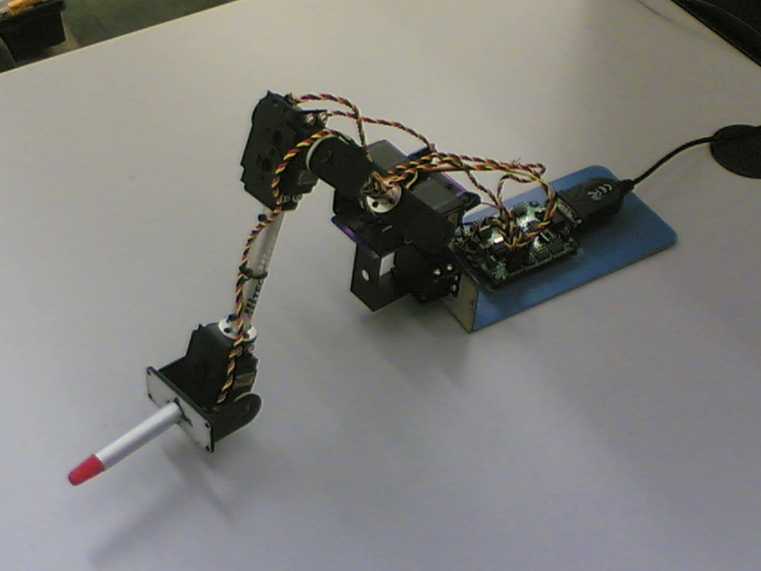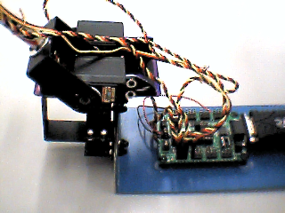

Fig. 2. Left: robotic arm, assembled at ISTC-CNR, which will be used to test the integrated architecture proposed here. Right: the base of the arm with the electronic card used to control it. A webcam, not shown in the pictures, “observes” the working area of the arm from above and constitutes the “eye” of the system.

The integrated architecture
The architecture of the model is shown in figure 2. The figure indicates the components of the architecture and the corresponding brain parts (in Italics and in brackets: see Kandel et al., 2000, for the location within the brain of such areas). The functioning and learning processes of the components of the architecture will now be explained in detail.

The components and the learning processes controlling the eye
The what area (infero-temporal cortex) is an area formed by three units with a binary activation, each detecting the presence or absence of a specific color (respectively Red, Green or Blue) in the retina. Notice that in the simulations the identity of possible targets is uniquely identified by the color and the position in space of them, so the task does not require shape recognition for the classification of “objects” appearing in the environment. We assume that the units of the what area activated only by information coming from the fovea of the retina (the central part of it). This is a very important assumption related to the role of attention for cognition. In fact it implies that attention is necessary for high-level visual processes like object recognition, but not for other processes as bottom-up attention and spatial localization (see saliency map below).

Pre-attentive maps. This component will have the function to generate signals in correspondence to potentially relevant locations in the image, on the basis of bottom-up processes. The pre-attentive filters typically detect simple features like colour, orientation, or contrast, but not the combinations of them. Itti and Koch (1998) presented an influential computational model of the human pre-attentive system and have shown how it can select locations that humans would attend in an image. In the model, three pre-attentive maps are combined into a salience map that in turn generates saccades between fixation points in the image. This allows us to immediately detect a red object among many green ones while it is much harder to detect a green horizontal bar among green and red horizontal and vertical bars. The aim of the Itti and Koch model was to parallel the visual search patterns of humans and is thus perhaps unnecessarily complex. The bottom-up attentional system used yere will be based on some specialised filter channels, for example:
- Absolute derivative on x-dimension and y-dimension (2 channels). The derivate calculations will use simple Sobel-filters followed by normalization and thresholding. Alternatively, a family of Gabor filters could be used to do more advanced filtering.
- Corner detection (1 channel). The corner channel will use the Harris-detector, which estimates the curvature at each pixel location. Used on a coarse scale, such a filter can be used to find objects against a homogenous background.
- Movement detection (1 channel). Since the camera will be stationary, the detection of movement might use the Stauffer-Grimson algorithm that learns the distribution of colors/gray-level values for each pixel in the image. This model is subsequently used to determine whether an image pixel belongs to the foreground or background. To use a moving camera this method could be generalized to a 3D-coding of the environment.
- Color (8 channels). The input image might be mapped onto the r-g chromaticity plane and split into 8 bands corresponding to primary colours. This coding makes it possible for the attention system to learn which colours should be salient in the task.
Salience map. This map (parietal cortex) will sum up signals from the bottom-up filters and will represent potential relevant targets for the attentional system. To allow different targets to be selected, each preattentive map is weighed by a learned parameter that indicates how important each channel is for a particular target object. The saliency of areas within the maps indicates potential targets for the active attention process that guides the eye saccades. Notice that the retina image (and hence the activation of the pre-attentive maps) is affected by the movements that change the position of the “eye” with respect to the environment. Here for simplicity we assume that the position of the eye is used to anchor to the external environment the representations of the saliency map.
The saliency map can be compactly represented as the convolution of a smoothing function G with a linear combination of the outputs from a number of individual pre-attentive maps F:
The parameters theta can be trained by reinforcement learning. If the output at each location is interpreted as a value function for a reinforcement learning system, the error after fixating a particular location can be calcuated as:
where r is the reinforcement received when looking at (x', y') and tau is the system delay between fixation on the obtainment of reinforcement. A learning rule for the theta parameters is the given by:
This learning rule will adjust the parameters to increase the probability that the system will attend to reinforced stimuli given that their position can be predicted by the outputs of the pre-attentive maps.
It is possible for the saliency map to use several sets of parameters (theta) to set up the system to look for different objects or features in the scene. This can be used for top-down priming of the attentional system. A possible mechanism for the learning of multiple parameter sets is the context sensitive associator reported by Balkenius and Winberg (2004).
Feature binding map. The what and where (saliency map) information are integrated by three feature binding maps. Each map is formed by 20×20 units and the centers of the receptive fields of the units are organized in a 20×20 grid that covers to whole visual field. The units of a map respond to a given color and activate in proportion to the topologically corresponding units of the saliency map. This is based on the simplifying assumption that the maps perform a simple combination of the where and what information, and so each of them encodes the locations of blobs of a particular color. This is a solution that is computationally very inefficient, and in the future it should be substituted by more efficient mechanisms for integration. A second important assumption is that the units of the feature binding map are activated only when the eye brings the fovea on their receptive fields: this assumption is based on the idea that the process that binds the where and what information takes place on the basis of attention. A third important assumption is that the units of the maps are leaky integrators: this allows the maps to implement a simple form of short term memory necessary to integrate information in time (this solution was already tested with success in Ognibene et al., 2006).
Inhibition of return. This component will have the function to “vote against” saccadic eye movements directed to already attended locations. This will be based on a habituation mechanism that learns to not attend to locations that have already been fixated.
Actor and accumulator-unit map. These components will have the same functioning as those controlling the arm (see below for details), but here they will be applied to the task of moving the eye of the system.
Eye posture controller. This component will encode the “desired muscle tensions” (more simply the eye desired x-y position) corresponding to a desired eye posture encoded in its input map.

Learning phases related to the eye. Due to the possibility of exploiting the linear transformations existing between the positions of targets on the retina image and the desired position of the “eye” in the arm’s working plane, the following parameters will be suitably hardwired (this will allow skipping the learning phases 1, 2 and 3 necessary for the arm and illustrated above):
- Correspondence between the actor’s output units and the accumulator units on one side, and the position of their “receptive fields” within the arm’s working plane.
- Weights of the actor responsible for selecting suitable eye’s desired postures: these will be set equal to +1.
- Weights of the eye posture controller: these will be set equal to the x-y “position” of the centre of the receptive field of the corresponding input unit (of the posture controller) on the arm’s working plane.

Adulthood phase: actor-critic’s reinforcement learning. This will be the only training of the architecture involving the components related to the eye. During the adulthood phase and the solution of the task, the actor controlling the eye will be trained on the basis of the same signal used to train the actor used to train the actor controlling the arm.

The components and the learning processes controlling the arm
The actor-critic components controlling the arm are a neural implementation of the actor-critic model (Sutton and Barto, 1998). The actor (basal ganglia’s matrix) is a two-layer feed-forward neural network with 20×20 input units, that correspond to the units of the retina, and 20×20 output units. The output units have a Sigmoid transfer function with activation y_{j} and each has a topological one-to-one connection (with weights equal to υ = +1) with the posture controller’s input units. The critic (basal ganglia’s striosomes and substantia nigra pars-compacta) is mainly composed of a neural network (“evaluator”) having a linear output unit. At each step t this output unit produces evaluations V_{t} of perceived states, and the critic uses couples of successive evaluations, together with the reward signal R_{t}, to compute the surprise signal S_{t} (dopamine):

where γ is a discount factor (γ = 0.3). The surprise signal is used for training both the actor and the evaluator (see below).

V_{t}
y_{j}
a’_{j} a_{j}
Critic
basal ganglia
striosomes
Accumulator units
premotor cortex
Posture controller
motor cortex
Learning phase (2), supervised
S_{t}
Actor
basal ganglia
matrix
Learning phase (3)
supervised
Retina
x_{i}
Kohonen network
parietal-premotor cortex
Learning phase (1), SOM
d_{k}
d’_{k}
w_{ji}
w_{i}
w_{kj}
V_{t-1}
R_{t}
-γ
+1
-1
Evaluator
Surprise signal
dopamine
+1
w_{jk}
Posture servomechanism
spinal cord
Learning and execution of arm’s sensorimotor primitives
Learning to select sensorimotor primitives
basal ganglia
Learning phase (4),
reinforcement learning
Decisions on which sensorimotor primitives should be executed
Arm’s angles
(muscle sensors)
What
Infero-temporal
cortex
Where: salience map
(absolute ref. system)
Parietal cortex
Pre-attentive maps:
e.g.: color change,
borders (derivative along x/y),
(visual associative cortex)
Fovea
Screen
Feature binding maps,
short term memory
(hippocampus, cortex)
ye_{j}
Invariances processing
(visual associative cortex)
Actor
basal ganglia
matrix
Arm’s muscles
ae’_{j} ae_{j}
Accumulator units
superior colliculus (?)
de’_{k}
we_{kj}
Eye’s muscles
Execution of eye’s sensorimotor primitives
Eye posture controller
motor cortex
Inhibition of attented locations
+1
Basal ganglia-
premotor cortex loops

Fig. 2. The neural components of the architecture with the corresponding brain areas in Italics. Symbols: grouping: broad functionalities implemented by the architecture’s main parts; bold arrows: all-to-all trained connections; thin arrows (only few of them are shown): one-to-one connections (weights = +1); dashed arrows: surprise learning signal; dotted arrow: delay connection; the weights of the critic’s one-to-one connections are indicated in the figure; dashed boxes: functionalities not implemented with neural networks.
The accumulator units (premotor cortex) form a 2D 20×20 map, have all-to-all lateral inhibitions, and have local excitations that decrease with distance on the map. The units engage in a many-winner competition on the basis of the signals (“votes”) that they receive from the actor’s output units via the one-to-one connections (Usher and McClelland, 2001; Schall, 2001). In particular, they behave as leaky-integrators and have an activation a_{j} as follows:

where τ is a time constant, corresponding to 1/10s, dt is the integration time step (dt = 0.05 1/10s, so dt/τ = 0.05; a_{j} is numerically updated every 0.005 s), χ regulates the speed of the dynamics (χ = 1), δ is a decay coefficient (δ = 0.1), ι regulates the all-to-all lateral inhibition (ι = 0.15), η regulates the local lateral excitation (η = 1), e_{k} represents the fixed weights of the lateral excitatory connections (e_{k} is set to 0.4 for neighboring units along the x/y-axes directions, to 0.2 for neighboring units along the diagonals, and to zero for all other units), ε_{jt} is a noise component that ranges over [-0.1, +0.1] and varies in each cycle, ε_{jc} is a noise component that ranges over [-0.25, +0.25] and is constant for time intervals c randomly drawn from [0, 5] s (ε_{jc} is important for exploration of reinforcement learning as various ε_{jt} tends to sum to zero over many steps). When the activation a_{j} of one accumulator unit reaches a threshold T (T = 1.9), the total activation of accumulator units is normalized to 1, their dynamics is “frozen”, and the execution of a reaching sensorimotor primitive is triggered.
The posture controller has an input-unit layer corresponding to the accumulator units and two Sigmoid output units, with activation d’_{k}, that range over [0, 1] (motor cortex/spinal cord neurons). The activations of these output units are remapped onto the arms’ angles and form the commands issued to the posture servomechanism in terms of arms’ desired angles (posture). It is important to notice that these desired angles are generated by the cluster of accumulator units that are active at the end of the many-winner competition. This implies that the target of the executed sensorimotor primitive is a mixture of the targets “suggested” by all active units: this population encoding (Pouget et al., 2003) allows the arm to cover the whole continuous space of postures.
The posture servomechanism is a hardwired closed-loop controller (Golgi tendon-organs, muscle-fiber afferents, and spinal cord, cf. Shadmehr and Wise, 2005) that issues commands to the arm’s actuators (muscles) on the basis of the desired-posture command received from the posture controller. In practice, this component simply changes the arm’s current angles in the direction of the desired angles, with maximum changes of 10 degrees.

Learning phases related to the arm. The learning processes take place in two phases, the childhood phase (three processes) and the adulthood phase (one process). Now we first present an overview of these learning processes and then describe them in detail.
During the childhood phase the system performs motor babbling: in practice the arm randomly varies its joints’ angles, with changes Δd’_{k} belonging to [-10, +10] degrees, without violating the joints’ constraints. Motor babbling is used for performing three learning processes. The first two processes allow the system to learn to perform sensorimotor primitives, in particular: (a) to train the 2D map of accumulator units, through a Kohonen algorithm (Kohonen, 2001), to represent the postures perceived by the proprioceptive units d_{k} (during the childhood phase the proprioceptive units, the accumulator units, and their connections, function as a Kohonen network); (b) to train the posture controller, through a Widrow-Hoff algorithm (Widrow and Hoff, 1960) (the generalized “delta rule”), to return as output the arm’s angles corresponding to postures encoded in the Kohonen map. These two training processes lead the whole network formed by the Kohonen network and the posture controller to implement an “auto associative” function (i.e., the arm’s angles encoded in the proprioceptive units are returned by the postural controller’s output units). This whole network allows the system to recode postures, at the level of accumulator units, in an expanded format suitable to perform actor-critic reinforcement learning (Sutton and Barto, 1998). Notice that suitable population encodings at the level of the accumulator units allow the system to select any posture in the continuous space of postures: this is precisely what the actor-critic components learn to do while solving reinforcement-learning reaching tasks in the adulthood phase.
With the third learning process of the childhood phase the system’s actor learns, through a Widrow-Hoff algorithm, to associate the point in space where the retina sees the arm’s “hand” (i.e., the forearm segment’s tip) with the activation pattern of the Kohonen map’s units corresponding to such point (pattern caused by the arm’s perceived angles). With this training, the actor acquires a bias to select sensorimotor primitives that drive the arm’s hand to points in space corresponding to the retina’s active units. This bias makes reinforcement learning performed during the adulthood phase quite fast notwithstanding the fact that the continuous space of postures is quite large. Note that two simplifying assumptions allow obtaining this result: (a) the retina does not perceive the arm and hand in the adulthood phase; (b) retina’s units activated by the hand in the childhood phase are activated by the LEDs in the adulthood phase.
During the adulthood phase the system learns by trial-and-error to accomplish Hikosaka’s task. The actor-critic model used to this purpose has been suitably modified to be capable of selecting “actions” represented with population encodings. The four learning processes are now illustrated in detail.

Childhood phase: training of the Kohonen network. During the childhood phase, while the system performs motor babbling, the accumulator units receive input signals from two input units, having activation d_{k}, that encode the arm’s current angles (remapped in [-1, +1]: this information is thought to be returned by proprioceptive sensors located in the muscles, e.g. Golgi tendon-organs and muscle-fiber afferents, Shadmehr and Wise, 2005). An extra pseudo input unit is used to perform a “z-normalisation” of the input pattern: this is a normalization that preserves size information (Kohnen, 2001). The accumulator units are trained with a Kohonen algorithm (Kohnen, 2001) that allows them to develop representations of the arm’s angles in their weights. The output units give place to a winner-take-all competition: the unit with the highest activation potential activates with 1 (“winning unit”), while the other units activate at levels decreasing with their distance from the winning unit on the basis of a Gaussian function. In particular, the activation a’_{j} of the unit j and the rule to update its weights w_{jk} are as follows:

where h_{fj} is the distance on the map between the unit j and the winning unit f (h_{fj} = 1 for two contiguous units), σ is the standard deviation of the Gaussian function (σ = 1), φ is a learning coefficient (φ = 0.01). Note that the Kohonen algorithm uses a winner-take-all competition to activate the accumulator units instead of the dynamic competition reported in equation 3, used in the adulthood phase: indeed, the former tends to lead to an activation of the accumulator units that approximates the steady state activation that the same units would get through the latter (Kohnen, 2001).

Childhood phase: training of the posture controller. The posture controller is trained on the basis of a direct inverse modeling procedure (Kuperstein, 1988) that exploits the random movements Δd’_{k} produced by motor babbling as follows: (a) the arm’s angles are perceived and categorized by the Kohonen net; (b) a Widrow-Hoff algorithm (Widrow and Hoff, 1960, learning rate = 0.3) is used for training the posture controller’s weights w_{kj} to associate the Kohonen-map units’ activation (input pattern) with the angles d’_{k} caused by the random movements considered as desired output.
Childhood phase: pre-training of the actor. Through this pre-training, based on a Widrow-Hoff algorithm, the actor’s weights w_{ji} are trained to associate the position of the hand perceived with the retina (input pattern x) with the corresponding posture (desired output a’) encoded in the Kohonen map (learning rate 0.1).
Adulthood phase: actor-critic’s reinforcement learning. During the adulthood phase, the actor-critic component is trained to solve the Hikosaka’s task by reinforcement learning. During training, R_{t} is set to 1 when the arm reaches the two targets of any set of the hyperset in the correct order, and to 0 otherwise. The evaluator is trained after the selection and execution of a whole sensorimotor primitive (the primitive terminates when the arm reaches the desired posture selected by the posture controller). In particular its weights w_{i} are trained, on the basis of a Widrow-Hoff algorithm (learning rate ψ = 0.6) and a TD-rule (Sutton and Barto, 1998), as follows:

Through this learning process, the evaluator’s evaluations V_{t} of the perceived states x_{t} tend to become higher for states corresponding to postures “closer” to reinforced states, and to form a gradient over the space of postures. The actor uses this gradient to learn to select highly rewarding sequences of primitives (Sutton and Barto, 1998). In particular the actor updates its weights w_{ji} with a Widrow-Hoff algorithm (learning rate ζ = 0.6):

where (y_{jt-1}(1-y_{jt-1})) is the derivative of the Sigmoid function. The functioning of this learning rule is illustrated in Figure 3. The rule tends to update only the weights of the units of the “winning cluster” because the activation a_{j} of other units tends to be zero at the end of the race. The votes of the winning units are decreased or increased in correspondence of respectively positive and negative surprises.
S_{t} > 0
S_{t} < 0
y_{t-1}+S_{t}a_{t-1}
y_{t-1}
y_{t-1}
y_{t-1}+S_{t}a_{t-1}

a_{t-1}
a_{t-1}

Fig. 3. Effects of the actor’s learning rule of equation 6 illustrated with a scheme relative to a 1D layer of actor’s output units (horizontal axis). Left: with a surprise S_{t} > 0, the actor’s votes y_{t-1} (upper graph), that caused certain accumulator units’ final activations a_{t-1} (lower graph), are moved toward the target y_{t-1}+S_{t} a_{t-1} (upper graph): this causes the votes of the winning cluster of accumulator units to increase (bold arrow) while other votes are not changed. Right: with a surprise S_{t} < 0, actor’s votes y_{t-1} are moved toward the target y_{t-1}+S_{t} a_{t-1}: this causes the votes of the winning cluster of accumulator units to decrease, while other votes are not changed

Preliminary results: the attention system
This section presents some results obtained by LUCS by testing the attention part of the architecture. In particular the experiments refer to an attentional controller more sophisticated than the one that will be used here (Figure 2). Parts of this controller will be used to actually implement the components of the attentional system of the integrated architecture.
Figure 4 illustrates an extended version of the attention model presented in Figure 2. There are four pre-attentive inputs from four pre-attentive maps. This is enhanced by a number attentive maps that models top-down influences on attention (in the integrated model, Figure 2, these will not be fully present). In the figure, the map a2 is a habituation map that learns spatial locations where a target is not likely to appear (in the integrated model, Figure 2, this will be obtained it an inhibition of return mechanism). The maps a3 and a4 are target maps that depend on spatio-temporal predictions about target locations based on previously fixated visual stimuli (the actor’s output map controlling the eye of the integrated system, Figure 2, might evolve in fashion similar to these maps).

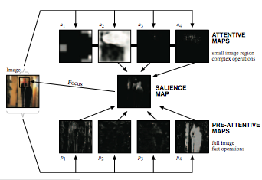
Fig. 4. The filters used here to illustrate the functioning of bottom-up (lower row of filters) and top-down attention (top row of filters).

A number of pre-attentive maps can be used. An important source of pre-attentive information comes from various forms of orientation filters. Figure 5 shows the saliency map controlled by the output of four Gabor filters that detect oriented contrast in the image in four directions. The yellow line illustrates the generated scan-path over the image which results from treating the saliency maps as the parameters for a Boltzmann distribution over all the possible target locations in the image. In this case, there is no learning involved.

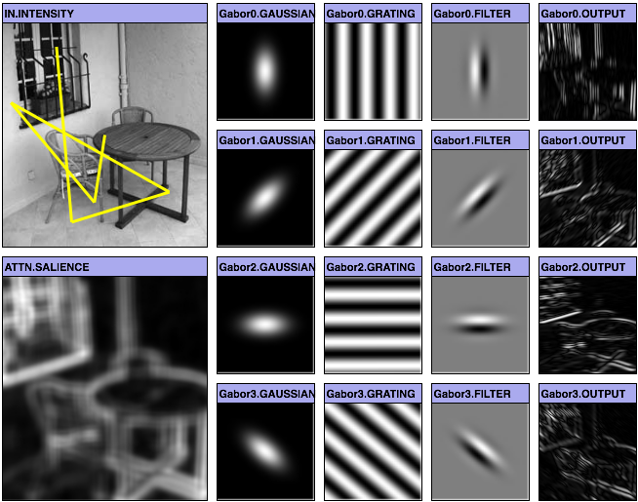
Fig. 5. The filters used here to illustrate the functioning of bottom-up and reinforcement learning guided top-down attention.
A more complex filter is the Harris detector, which finds locations in the image with high curvature, such as corners (Harris and Stephens, 1988). Another useful pre-attentive complex filter can be derived from the output from a Stauffer-Grimson forground/background segmentation that learns the distribution of colours of the background pixels and uses this to detect forground pixels (Stauffer, 1999). Figure 6 shows the output of the filter applied to a film with two moving persons.
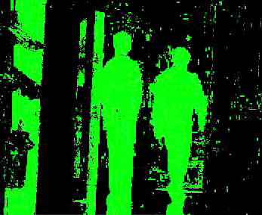
Fig. 6. The output of a Stauffer-Grimson forground/background filter.
Figure 7 shows the gaze over an image when the system illustrated in Figure 4 has been reinforced for looking at faces. The attention model has learned to direct attention to regions in the scene where faces are likely to be, given the output of the different pre-attentive maps. Note that the gaze is not controlled by any face detector.

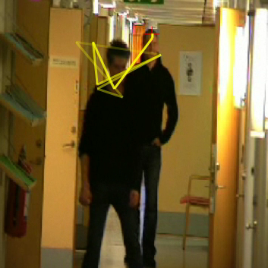
Fig. 7. The figure illustrates the fixation points of a top-down attention system rewarded for fixating faces, whose input is formed by the output of some bottom-up filters as those illustrated in Figure 4.

Preliminary results: the arm
Now we present some tests that prove the computational soundness of the model, illustrate the functioning of its components, and show its capacity to learn sensorimotor primitives, by motor babbling, and to compose sequences of them, by reinforcement learning, on the basis of their population encoding.

During the first training of the childhood phase, the Kohonen network’s error (measured as the average over 1,000 cycles of the square of the norm of the difference between the vector of weights and the vector of the input pattern) decreases from 0.411 to 0.034 after 600,000 random arm’s movements. After this training the network learns to represent the whole perceived postural space by using its units in a statistically well-distributed fashion (Figure 8, left graph). This representation is at the basis of the population encoding of postures used in the adulthood phase.

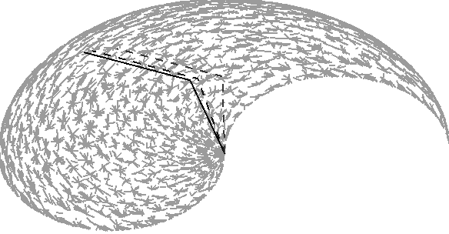
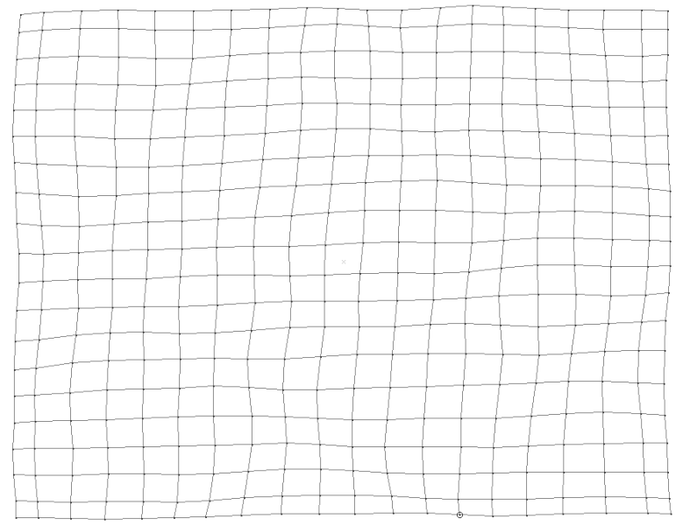

Previous posture
Net’s output posture
Target posture

Fig. 8. Left: result of the training of the Kohonen network. Each vertex of the grid represents a node of the Kohonen map, and its x-y coordinates correspond to the node’s two weights encoding the arm posture. Right: errors of the posture controller after training, collected while the arm produces several random movements; the graph represents the errors as gray segments plotted between the x-y positions of the hand corresponding to the target actual posture (e.g., black arm) and the position that the hand would have achieved on the basis of the posture controller’s output pattern (e.g., dark gray dashed arm; the light gray dashed arm indicates the previous posture assumed by the arm during motor babbling)
During the second training of the childhood phase, the posture controller’s error (measured as the average over 1,000 cycles of the distance between the point reached by the arm and the target point) decreases from 8.62 cm to 1.19 cm. Note that this error cannot become very low since the Kohonen network’s units are activated on the basis of a Gaussian function centered on the winner units, that are in a finite number, while the desired output belongs to the whole continuous space of arm’s postures. Indeed, the right graph of Figure 8, which shows the residual errors after training, indicates that the hand tends to reach only few specific points corresponding to the vertex of a grid that covers the whole postural space (this grid is explicitly represented in Figure 9, right graph). In the adulthood phase, this problem is overcome by the population encoding of postures resulting from the accumulator units’ activation.

During the third training of the childhood phase, the actor’s error (measured as the output units’ mean error averaged over 1,000 cycles) decreases from 0.513 to 0.052. This training leads the system formed by the actor, accumulator units, and postural controller to acquire the capacity to perform fine reaching movements in the continuous space of postures even if the accumulator units cover such space at a gross granularity. This can be illustrated by showing the system a sequence of 100 targets positioned along a circumference having a ray of 10 cm and located near the arm’s shoulder (see Figure 9, right graph). The left graph of Figure 9, which shows the errors between the targets and the points reached by the hand in the test, indicates that the errors are very small (mean: 3.2 mm). Moreover, and more importantly, the system succeeds in reaching virtually any point in the continuous space of postures even if the accumulator units cover such a space with a gross granularity. This skill depends on the mentioned accumulator units’ capacity to represent postures by population encodings.
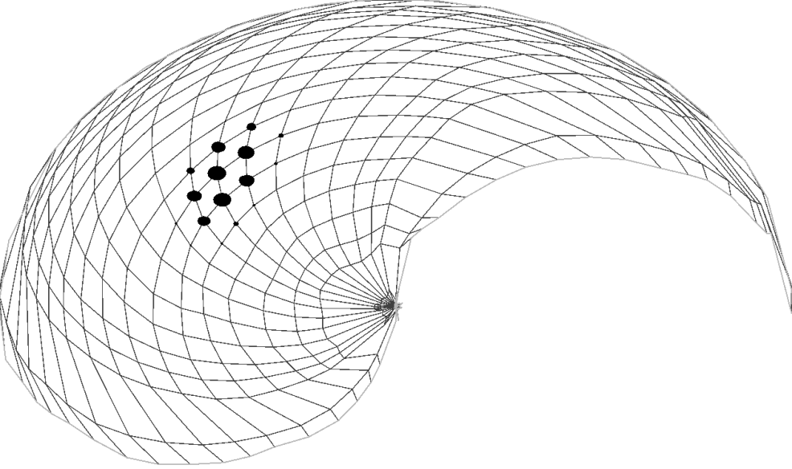


Fig. 9. Left: errors (indicated by the gray segments) between 100 target points positioned on a circumference (shown in the right graph) and the corresponding points reached by the hand. Right: activation (proportional to the size of the full dots) of the actor’s output units caused by a target. The positions of the dots and vertexes of the grid plotted in the graph correspond to the positions of the hand related to the “postures” encoded in the accumulator units’ weights of the posture controller
So far, the trial-and-error learning skills of the system in the adulthood phase have been tested with a simplified version of the task: two color blobs are presented together, and the system has to learn to reach one of them by trial and error (a reward of 1 is given when the hand reaches the correct target. The results with this task show that the pre-training of the actor gives it a useful bias to reach the targets perceived by the retina. In particular the left graph of Figure 10, reporting the activations of the actor’s output units when the system sees two targets, shows that the units that “vote” for the two possible correct arm’s postures form two clusters and have an activation higher than that of other units. The same figure (right graph) shows that the two clusters compete, at the level of the accumulator units, and only one of them “survives” and triggers the corresponding arm’s posture when the activation of one of its units reaches the threshold.

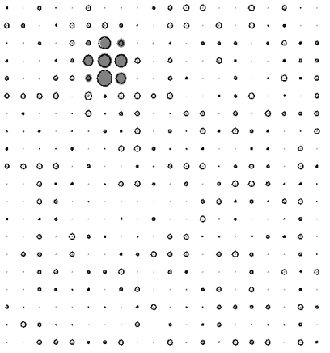



Fig. 10. Left: activations of the actor’s output units before adulthood training caused by the perception of two targets (the area of the gray dots and black circumferences is proportional to the units’ activations respectively before and after the addition of noise); the two arrows indicate two clusters of units with activation higher than that of the other units due to the actor’s pre-training. Right: activation of the same units after training; notice how one of the two clusters has been strengthened while the other one has disappeared; the activation of the units of the strengthened cluster cause an activation of the accumulator units, at the end of the race, as plotted in the bottom right small graph

References
Balkenius, C., Åström, K. and Eriksson, A. P. (2004). Learning in visual attention. In ICPR '04 workshop on learning for adaptable visual systems (LAVS).
Balkenius, C., and Johansson, B. (2005). Event Prediction and Object Motion Estimation in the Development of Visual Attention. Proceedings of the Fifth International Conference on Epigenetic Robotics. Nara, Japan.
Balkenius, C., and Johansson, B. (2006). A developmental approach to dynamic scene understanding. Proceedings of the Sixth International Conference on Epigenetic Robotics (p. 165). Lund University Cognitive Studies, 128.
Balkenius, C., and Winberg, S. (2004). Cognitive modeling with context sensitive reinforcement learning. In Proceedings of AILS '04. Lund: Dept. of Computer Science.
Cisek, P., & Kalaska, J. (2005). Neural correlates of reaching decisions in dorsal premotor cortex: specification of multiple direction choices and final selection of action. Neuron, 45, 801-814.
C.Harris & M.Stephens (1988) A combined corner and edge detector, Proc. of 4th Alvey Vision Conf., 147-151.Balkenius, C., Åström, K. and Eriksson, A. P. (2004). Learning in visual attention. In ICPR '04 workshop on learning for adaptable visual systems (LAVS).
Houk, J.C., Davis, J.L., Beiser, D.G. (eds.): Models of Information Processing in the Basal Ganglia. MIT Press, Cambridge MA (1995)
Kandel, E.R., Schwartz, J.H., Jessell, T.M.: Principles of Neural Science. McGraw-Hill, New York (2000)
Kohonen, T.: Self-Organizing Maps. 3rd edn. Springer-Verlag, Berlin Heidelberg New York (2001)
Kuperstein, M.: A Neural Model of Adaptive Hand-Eye Coordination for Single Postures. Science 239 (1988) 1308-1311
Ognibene D., Mannella F., Pezzulo G., Baldassarre G. (2006). Integrating reinforcement-learning, accumulator models, and motor-primitives to study action selection and reaching in monkeys. In Fum D., Del Missier F., Stocco A. (eds.), Proceedings of the Seventh International Conference on Cognitive Modeling (ICCM2006), pp. 214-219. Trieste, Edizioni Goliardiche.
Ognibene D., Rega A., Baldassarre G. (2006b). A Model of Reaching That Integrates Reinforcement Learning and Population Encoding of Postures. In Nolfi S., Baldassarre G., Calabretta R., Hallam J., Marocco D., Miglino O., Meyer J-A, Parisi D. (eds.). From animals to animats 9: Proceedings of the Ninth International Conference on Simulation of Adaptive Behaviour, LNAI. Volume 4095. Berlin, Germany: Springer Verlag.
Pezzulo G., Baldassarre G., Butz M. V., Castelfranchi C., Hoffmann J. (2006). An analysis of the ideomotor principle and TOTE. In Butz M. V., Sigaud O., Pezzulo G., Baldassarre G. (eds.), Proceeding of the Third Workshop on Anticipatory Behaviour in Adaptive Learning Systems (ABiALS 2006). Rome, Istituto di Scienze e Tecnologie della Cognizione, Consiglio Nazionale delle Ricerche (ISTC-CNR).
Pouget A., Lathaam P. E.: Population Codes. In : Arbib, M. A. (ed.): The Hand-book of Brain Theory and Neural Networks. MIT Press, Cambridge MA (2003) 893-897
Stauffer C.. Adaptive background mixture models for real- time tracking. In Proc. Conf. Computer Vision and Pattern Recognition, pages 246–252, 1999.
Schall, J.D.: Neural Basis of Deciding, Choosing and Acting. Nature Reviews Neuroscience 2 (2001) 33-42
Shadmehr, R., Wise, S.: The Computational Neurobiology of Reaching and Point-ing. MIT Press, Cambridge MA (2005)
Sutton, R.S., Barto, A.G.: Reinforcement Learning: An Introduction. MIT Press, Cambridge MA (1998)
Usher, M., McClelland, J.L.: On the Time Course of Perceptual Choice: The Leaky Competing Accumulator Model. Psychological Review 108 (2001) 550-592.
Widrow, B., Hoff, M.E.: Adaptive Switching Circuits. IRE WESCON Convention Record, Part 4 (1960) 96-104

NBU and LUCS: Integrating AMBR and IKAROS

Introduction
This section describes the work done by NBU and LUCS for building an integrated architecture for real-world robot problem solving within Scenario 1 – “Finding and Looking for” (deliverable 2.1). We have integrated the AMBR system developed by NBU with the IKAROS system developed by LUCS and implemented them into a single AIBO robot looking for his/her bone hidden somewhere in a room. The AIBO robot perceives the room and its content via a camera, builds internal representation of the objects in the room and their relationships, recalls an analogous situation from the past, makes an analogy and predicts where the bone might be hidden, and eventually moves towards the predicted place into the room. The results are still preliminary and we have many steps to go further, however, the full cycle is running and more importantly, there is an interaction between the processes of perception, attention, memory retrieval, and mapping. These interactions promise interesting results related to greater flexibility and efficiency. The last year of the project will be used for experimenting with the current version, further development of an extended version, which will allow greater flexibility and more sophisticated bottom-up and top-down interaction within the perceptual process.

Brief Summary of Previous Work
The past work on the AMBR model for analogy making is summarized in (Petkov et al. 2006). The idea for building predictions using analogy with a single past episode has been developed. The AMBR model was extended with new mechanisms for transferring possible solutions of the target problem from memorized past episodes. After the manually performed description of the target problem is attached to the system input. The best analogy emerge form the input interactions between a large number of agents. After this the new instantiation mechanisms transfers the solution from the bases to the target. Both mechanisms for augmentation of the target and the base situations were successfully tested with various simulation experiments.
In addition, the attention bias was simulated by adding different elements of the target at the architecture input. The role of this attention bias for the choice of base for analogy was explored in 16 series of simulations. The results are published in (Petkov et al. 2006).
We successfully developed a simulated robot using AMBR in the robot simulation environment Webots. The simulation was tested in several simple scenario tasks, related to Scenario 1. To link AMBR with Webots we built a new software module – Middle tier which implements the information transfer between them. In one direction it gets a simplified scene description from the Webots environment standing for a symbolic representation supplied by a pseudo ‘visual system’. In the other direction, it creates motion plans from AMBR commands ordering which are executed in Webots. These results are described more detailed in deliverable 2.2.

Environment and Scenario Description
The developments reported here consist first of all of the use of AMBR in its present state with real robots and in combination with IKAROS (provided by LUCS). For the tasks at hand (to be described later) we used a Sony AIBO robot (ERS-7). The robot vision was organized as follows. In order to simplify the problems related to 3d vision we chose to have one camera attached on the ceiling having a global 2D view of the scene. A web camera server sent the image data via TCP/IP to the network camera module of IKAROS.

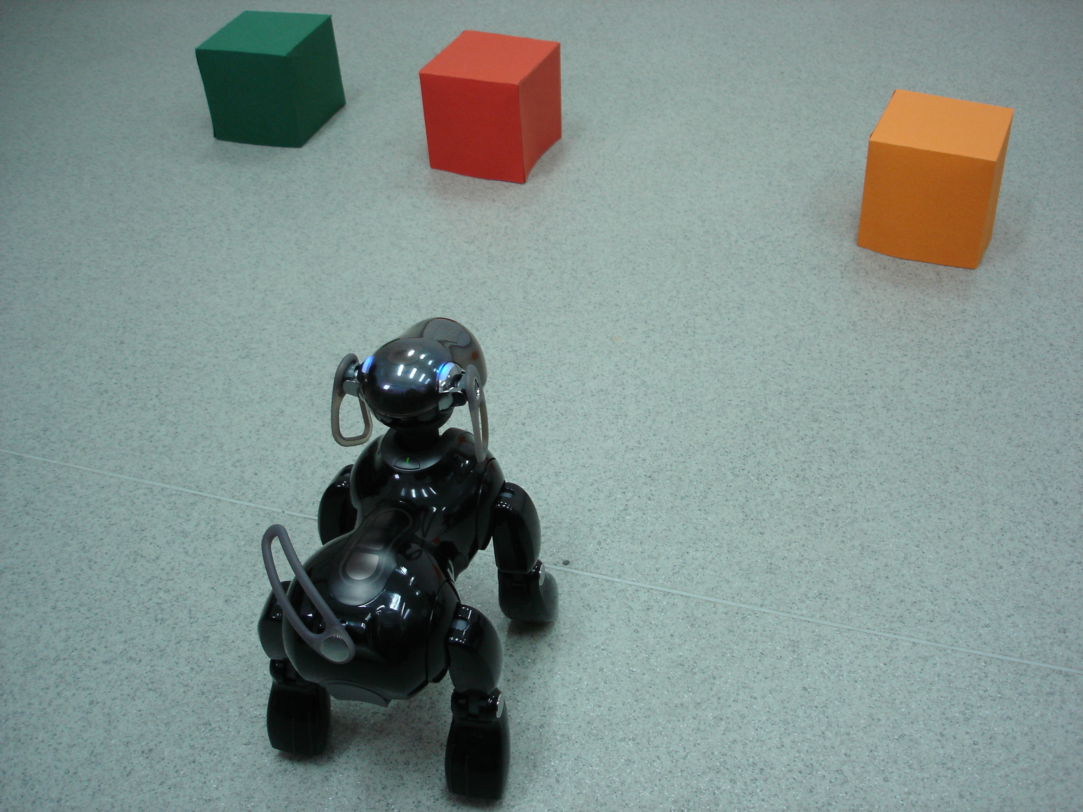
Fig 1. AIBO robot in “Finding and Looking for” scenario

The tasks that were considered are similar the ones implemented as simulations in Webots. Except for the robot itself, the scene includes cylinders and cubes with different colors (see Figure 1). The AIbone was hidden under one of the shapes. No overlapping of the shapes is allowed. There are no shapes put above other.
The AIBO had to predict based on analogies with past episodes where the bone is hidden and go for it.

Fig. 2. Old episodes in memory used in the experiments (bases)

Fig. 3. Situations ‘perceive’ by the AIBO (target situations)

The Integrated Architecture
In its previous versions AMBR lacked completely any perceptive mechanisms except for manual coding of a presented situation (target) and additionally perceived objects. A major step for the NBU team was to built in collaboration with LUCS a perceptive mechanism with active vision elements based on the platform IKAROS as planned in deliverable D6.2. Several modules of IKAROS related to perception and selective attention were successfully integrated. We use some modules of IKAROS to manage with the difficult task of visual perception and object recognition. Thus we have enriched our model AMBR with missing perception abilities. It gives us the possibility to extract from real physical environment and not coding it manually inside the model. A new module –AMBR2ROBOT is developed as general mediating layer between the perceptions modules of IKAROS and ABMR. It is based on the so-called ‘Middle tier’ - developed to interface AMBR and Webots. AMBR2ROBOT supports the selective attention mechanisms, which will be described in detail below. Figure 4 shows the main modules of the integrated architecture and links between them.

Fig. 4. Main modules and data flow between them

IKAROS
IKAROS is an open software system for brain modeling. It is developed by LUCS (http://www.ikaros-project.org/). It includes a large number of modules modeling different cognitive processes some of which for visual input processing. Some of the modules are very useful for current tasks in the integrated architecture like:
- Edge detection – different edge filters to the image (useful recognizing shapes)
- Network camera – connection with the camera
Additionally to the already existing modules, LUCS developed a new module for the purpose of integration with AMBR.. It processes the visual data and outputs a partial symbolic encoding of the scene, which includes discovered objects and some of their characteristics, e.g. with their colour and shape based on an edge histogram.

AIBO Remote Framework
AIBO Remote Framework is a Windows PC application development environment which enables the communication and control with AIBO robots via wireless LAN. The software is free and can be downloaded from AIBO SDE website (http://openr.aibo.com/).
The architecture involving the AIBO Remote Framework has the following modules (see Figure. 4):
- Application – user application that utilizes AIBO Remote Framework
- AIBO Remote Framework API - AIBO Remote Framework libraries
- Virtual AIBO Server – the server program which connects AIBO and the AIBO Remote Framework application

Fig. 4. Using AIBO Remote Framework
Using this API AIBO can be controlled from software running on PC, offloading robot from processing power. With RF API users could focus on high level programming for robot instead of considering each movement primitive.
The following functions of RF API are used:
- Walk forward, turn left right, Stop - DoWalking( DW_FORWARD | DW_TURN_LEFT… ,…)
- Set standing posture - SetPosture(POS_STAND_V,…)
- Turn over object - DoHeader (DH_FORWARD,…)
- Get the bone - DoRobotFunction (ROBOTFUNC_AIBONE_APPROACH,…)

AMBR2ROBOT
AMBR2ROBOT mediates between AMBR, IKAROS and the robot. For that purpose the module builds scene-representation based on the information, which comes from IKAROS. The representation includes:
- objects-id - a list of unique identifiers of the objects discovered by the robot in the environment
- object properties – coordinates , color , shape , orientation (for the Robot)

The work of the module AMBR2ROBOT formally can be divided into three subprocesses:
- Bottom-up perception
- Top-down perception
- Performing actions
Description of the different stages follows below.

1. Bottom-up perception
In this stage just a small part of the scene-representation is sent to AMBR. It includes:
- objects-id
- objects type (shape)
The latter is further transformed into the form used for knowledge representation in AMBR by creating a set of AMBR agents with appropriate slots and links and connecting them to the so-called input of the architecture.

Other information sent to AMBR is
- description of the goal – a list of manually predefined interconnected AMBR agents, which describe the information that “the goal-state is Aibo to find the bone”.

2. Top-down perception
It is known that when executing a task in order to achieve a specific goal top-down mechanisms are predominant (Duncan 1984, Chalmers et al. 1992). This finding is implemented by making AMBR the initiator for information acquisition. The needed information is requested by AMBR in the form of questions about the presence of properties and relations about the identified objects. These request are received by AMBR2ROBOT and are answered (basically a no/yes response) based on visual symbolic information provided by IKAROS. Relations represent the most important information for analogy making and are extracted by AMBR2ROBOT from the scene description which do not contain them explicitly but only implicitly (e.g. in the form of coordinates and not spatial relations). The relation requests have the following form:
{relation-name relation-concept arguments}.
Where relation-name is the unique name of an instance (token) of an anticipation relation agent (see 3.4); relation-concept is the concept (type) of the relation and arguments are names of agents, which corresponds to the objects-ids in the scene-representation of AMBR2ROBOT.
For example:
{left-of-1 left-of object-2 object-1}.
The main types of relation concepts available are:
- spatial relations: right-of, in-front-of, in-front-right-of, etc…
- sameness relations: same-color, unique-shape, etc…
- colour relations: orange, blue, red, etc…

As mentioned above the spatial relations are checked based on the objects’ positions as described by their coordinates and size and with respect to the gaze direction of the robot. Answers available to AMBR are:

- Yes – the relation “is true”
- No – otherwise
- Unknown – the robot doesn’t have enough information to give a precise answer

Thus, similar to the Copycat model (Hofstadter et al. 1994), it is assumed that the system uses a simple information filtering mechanism providing answers which are produced using only the robot partial knowledge about the world.

3. Action
AMBR2ROBOT receives action commands from AMBR and knowing the positions of the target object and the robot it (AMBR2ROBOT) navigates AIBO by sending movement commands via the AIBO Remote Framework (see Figure 4). During the executed motion, IKAROS is used to update the robot’s position in the scene (the other objects in the scene are assumed to have fixed positions) and only the robot is actually being tracked). The robot is guided directly to the target object without any object avoidance (to be implemented in more sophisticated examples).After arriving at the requested position the robot uncovers the object and takes its bone if it is there or stops.

Development of AMBR for Robot Applications
In order to make AMBR a model of the mind of a real robot several new mechanisms were developed and implemented. First of all AMBR was translated from Common Lisp to C# with update of all its basic mechanisms. Most importantly several analogical transfer mechanisms have been found which will allow robust anticipation based on analogy – the main contribution of NBU to the project in terms of model integration. The present development is related to the enlargement of the model with a dynamic top-down perceptual mechanism, with a control of attention, with mechanisms for transferring parts from a base episode in memory towards a target episode (analogical transfer), and with mechanisms for planning and ordering actions based on that transfer. For a brief description of all old and new mechanisms see Table 1, whereas for the various AMBR agent’s types see Table 2. Note that all these mechanisms overlap during the time and influence each other. In addition, there is no any central executor in AMBR. Instead, the AMBR agents interact only with their neighbors and perform all operations locally, with a speed, proportional to their relevance to the current context.

Old mechanisms
Spreading activation | The activation of the agents represents their relevance to the current context. It spreads just like in a neural network. The sources of the activation are two special nodes – INPUT and GOAL. The AMBR agents that represent the environment are attached to the INPUT, whereas the representation of the target is attached to the GOAL.
Marker emission and passing | Each instance-agent (representing a concrete token) emits a marker that spreads to the respective concept-agent (representing type) and then upward to the class hierarchy. When a marker from the target situation crosses somewhere a marker from a memorized situation, a hypothesis-agent between the two marker-origins is created. The hypothesis-agents always connect two agents and represent the inference that these two agents are analogical.
Structural correspondences | There are various mechanisms for structural correspondence that create new hypotheses on the basis of old ones. For example, if two relations are analogical, their respective arguments should also be analogical; if two instance-agents are analogical, their respective concepts should also be analogical, etc.
Constraint satisfaction network | The consistent hypotheses support each other, whereas the inconsistent ones compete each other. Thus, dynamically, a constraint satisfaction network of interconnected hypotheses emerges. After its relaxation, a set of winner-hypotheses, which represent the performed analogy, is formed.
New mechanisms
Anticipation (top-down perception) | By a series of messages, the instance-agents from memorized situations inform the relevant relations in which they participate for all their hypotheses. If a certain relation collects the hypotheses for all its arguments, it creates an anticipation-agent. The anticipation-agents are copies of their mentor-relations but all their arguments are replaced with the respective analogical elements from the target situation.
Attention | The attention mechanism monitories all anticipation-agents, sort them by their activation (i.e., relevance), and at the fixed time intervals asks the perceptual system to check the most active one.
Transfer of the solution | When a certain hypothesis transforms itself to a winner-hypothesis, it informs its base element. The latter, on turn, informs the relations, in which it participates. The respective relations erase all anticipations and hypotheses that are inconsistent with the new winner. Thus, actually, the anticipation mechanism creates many different possible solutions of the problem that compete each other, whereas the transfer mechanism works by deleting most of them on the basis of the best analogy. As a final result of the transfer mechanism only the solution that is most consistent with the performed analogy remains.
Action | The cause-agents (representing causal relations) are equipped with a special routine. Via special messages, the agents, attached to the GOAL node inform the cause-relations, in which they participate, that the latter are close to the goal. After a period of time, if such ‘close-to-goal’ cause-agent receive information that it participates in a winner-hypothesis, it checks its antecedents for action-agents (representing description of a certain action or movement). If all these conditions happened, the action mechanism sends order for executing the respective action.

Table 1. Old and new mechanisms, used by AMBR

Instance-agent | Represents tokens, i.e., particular exemplars. The instance-agents can represent objects, as well as aspects and relations. | Examples:  bone-1, red-21, behind-3…
Concept-agent | Represents types, i.e., classes of similar exemplars. Again can represent objects or relations. | Examples:  bone, color, behind…
Hypothesis-agent | Always connects two elements – one from the target situation and one from a memorized one. Represents an inference that there is something in common between the two elements – they have common super-class or they are respective arguments of corresponding relations. | Examples:  bone1<-->bone-3,  left-of<-->right-of,  red-12<->green-8…
Winner-hypothesis | Represent already established analogical correspondence between two elements. The hypothesis-agents become winners or fizzle out. | The same form like the hypothesis-agents
Anticipation-agent | Represents expectation that a certain relation is presented in the environment. | Examples:  ?red-cube-12?,  ?behind-bone-cylinder12?…
Cause-agent | Represents a certain casual relation. It always has antecedents and consequences. One cause-agent can be instance-agent or anticipation-agent. | Example:  Cause1  - antecedents: move-12, behind-2  - consequences: find-8
Action-agent | Represents the description of a certain action or movement. The presence of an action-agent in the target situation does not mean its necessary execution. In order Aibo to execute the respective action, a special procedure for this should be triggered. | Examples:  Move (Aibo, cilynder-12),  Rotate (Aibo, head, 30⁰)…

Table 2. The main agent’s types, used by AMBR

Anticipation (Top-Down Perception)
At the beginning, the robot is looking at a scene. In order for the model to ‘perceive’ the scene or parts of it the scene must be represented as a scheme like episode, composed out of several agents standing for objects or relations, attached to the input or goal nodes of the architecture. It is assumed that the construction of such a representation is initially very poor. Usually, symbolic representations of only the objects from the scene without any descriptions are attached to the input of the model (for example, cube-1, cube-2, and cube-3). The representation of the goal is attached on the goal node (usually find-t, Aibo-t, and bone-t). During the run of the system, via the mechanisms of analogical mapping some initial correspondence hypotheses between the input (target) elements and some elements of the memory episodes (bases) emerge. The connected elements from the bases activate the relations in which they are included. The implemented dynamic perceptual mechanism creates anticipations about the existence of such relations between the corresponding objects in the scene. For example, suppose that cube-T from the scene representation has been mapped onto cube-11 in a certain memory situation. The activation retrieval mechanism adds to working memory some additional knowledge about cube-11 – e.g. that it is yellow and is positioned to the left of cube-22, etc. The same relations become anticipated in the scene situation, i.e. the system anticipates that cube-T is may be also yellow and could be on the left of the element, which corresponds to cube-22 (if any), etc. Thus, various anticipation-agents emerge during the run of the system.

Attention
The attention mechanism deals with the anticipations generated by the dynamic perceptual mechanism, described above. With a pre-specified frequency, the attention mechanism chooses the most active anticipation-agents and asks the perceptual system to check whether the anticipation is correct (e.g. corresponds to an actual relation in between the objects in the scene). AMBR2ROBOT, as described earlier, simulates the perceptions of AMBR based on input from a real environment (using IKAROS). It receives requests from AMBR and simply returns an answer based on the available symbolic information from the scene. As was mentioned before the possible answers are three: ‘Yes’, ‘No’, or ‘Unknown’. The answer ‘Unknown’ is returned very often because typically AMBR asks for a variety of relations. In addition to colors (‘color-of’ relations), spatial relations, positions, etc., it generates also anticipations like “the bone is behind ‘object-1’”, or “if I move to ‘object-3’, I will find the bone”. Those relations play a very important role for the next mechanism – the transfer of the solution (i.e. making a firm prediction on which an action will be based) – as explained below.
After receiving the answers, AMBR manipulates the respective agent. If the answer is ‘Yes’, it transforms the anticipation-agent into instance-agent. Thus the representation of the scene is successfully enlarged with a new element, for which the system tries to establish correspondences with memory episode elements. If the answer is ‘No’, AMBR removes the respective anticipation-agent together with some connected to it additional anticipations. Finally, if the answer is ‘Unknown’, the respective agent reminds anticipation-agent but emits marker and behave just like a real instance, waiting to be rejected or accepted in the future. With other words, the system behaves in the same way if the respective anticipation is true. However, the perceptual system or the transfer mechanism (see below) can remove this anticipation.

Transfer of the Solution
Thus, the representation of the scene emerges dynamically, based on top-down processes of analogical mapping and associative retrieval and of the representation in AMBR2ROBOT and its functioning. The system creates many hypotheses for correspondence that self-organize in a constraint-satisfaction network. Some hypotheses become winners as a result of the relaxation of that network and in this moment the next mechanism – the transfer of the solution does its job. In fact, the transfer mechanism does not create the agents, which represent the solution. Actually, the perceptual mechanism has already transferred many possible relations but now the task is to remove most of them and to choose the best solution. For example, suppose the target situation consists of three red cylinders and let the task of AIBO is to find the bone. Because of various mappings with different past situations the anticipation mechanism would create many anticipation-agents with the form: “The bone is behind the left cylinder” because in the sit-001 the bone was behind the left cube and now the left cylinder and the left cube are analogical. Because of the analogy with sit-002, for example, the anticipation that “the bone is behind the middle cylinder” could be independently created. For a third reason, the right cylinder may be also considered for a candidate for searching the bone. Thus many concurrent possible anticipation-agents co-exist. When some hypotheses win, it is time to disentangle the situation.
The winner-hypotheses care to propagate their winning to the consistent hypotheses that comprise anticipation-agent. In addition, the inconsistent ones are removed. In the example above, suppose that the sit-001 happens to be the best candidate for analogy. Thus, the hypothesis left-cylinder<-->left-cube would become a winner. The relation ‘behind’ from the sit-001 would receive this information and would care to remove the anticipations that the bone can be behind the middle or behind the right cylinder.
As a final result of the transfer mechanism, some very complex causal anticipation-relations like “if I move to the object-3, this will cause finding the bone” become connected with the respective cause-relations in the bases from memory via winner-hypotheses.

Action Executing
The final mechanism is sending an action command. The cause-relations that are close to the GOAL node trigger it. The node GOAL sends a special message to the agents that are attached to it, which is in turn propagated to all cause-relations. Thus, at certain moment, the established cause-relation “if I move to object-3, this will cause finding the bone” will receive such a message and when one of its hypotheses become winner, it will search in its antecedents for an action-agents. The final step of the program is to request the respective action and this is done again by a message to the middle layer of the system.

Future plans
Our plans for the close future work are to implement bottom-up perceptual mechanisms, to improve the attention mechanism, and to enlarge the model with various types of different actions.
We plan future integration with IKAROS system at the level of bottom-up perceptional system. IKAROS is able to create various salience maps on the basis of the perceptual input and the goals of the system. AMBR can use these salience maps in order to activate various concepts and with different degree. This contextual information will influence with a higher degree the retrieval processes. Note that in the current version of the model the bottom-up perceptions are poorly simulated by manual activation of one and the same pattern of concepts for all targets.
The attention mechanism should be connected with the robot camera and particularly, with its gaze. Thus, both the salience maps and the top-down reasoning will influence the head-movement of the robot, and in turn, the order of checking the various anticipations. Global camera could be used further but then will be provided more comprehensive mechanism for filtering the visual info according to the robot point of view providing it with the only information robot can actually see.
Top-down relation requests will have for arguments not only instances of objects but and object concepts. For example:
? in-front-of cube AIBO-t (is there any cube in front of the robot?)
The integration between all these mechanisms – bottom-up, top-down perception, and control of attention will, on one hand, put additional constraints for the other mechanisms, and on the other hand, give opportunity to test AMBR in much more complex situations.
Finally, the repertoire of possible actions that AIBO can do should be enlarged. In the current version of the model AIBO is able only to move from its initial position to one predefined object. However, it is not yet implemented how it can do this if there are obstacles.
At the end, our long-term plans are to develop also learning and emotional mechanisms, as well as testing AIBO behavior in more complex situations that include social interactions. We plan also to develop various mechanisms for ‘understanding the task’, e.g. to break up one abstract goal onto several smaller sub-goals on the basis on analogy with past situations.
In the current implementation all memorized situations are manually predefined and stay static. Our plans are the new situations, together with their solutions or failures to be included in the LTM for future use.
We assume the emotional control as a manipulation of the global parameters of the model. Thus, for example, a decreasing of the WM can be interpreted as a fair and will cause more superficial and less consistent analogies to be done, but for compensation this will be done much faster.
Our plans for modeling social interactions include at least two robots. One of them will hide the bone, whereas the other one will seek it. Both robots will have various anticipations (and possibly meta-anticipations) about the behavior of the other one.
Finally, for breaking up the goals onto sub-goals we rely on integration with our partners in MindRACES project UW-COGSCI, IDSIA, who have mechanisms for planning, action, and action monitoring.

References
Petkov, G., Naydenov, Ch., Grinberg, M., Kokinov, B. (2006). Building Robots with Analogy-Based Anticipation. In: Proceedings of the KI 2006, 29th German Conference on Artificial Intelligence, Bremen, in press.
Duncan, J. (1984). Selective attention and the organization of visual information. Journal of Experimental Psychology: General, 113, 501-517.
Chalmers, D., French, R. & Hofstadter, D. (1992). High-level perception, representation, and analogy: A critique of artificial intelligence methodology. Journal for Experimental and Theoretical Artificial Intelligence, 4, 185-211.
Hofstadter, D. & Mitchell, M. (1994). The Copycat project: A model of mental fluidity and analogy-making. In Holyoak, K. & Barnden, J. (eds.): Advances in connectionist and neural computation theory, vol. 2: Analogical connections. Ablex: Norwood, NJ.

ISTC-CNR and IST: Integrating Emotions into Anticipation Behaviors

Introduction
Synthetic models of behaviour able to perform well in real time worlds require anticipatory competences. Our recent researches are showing that agent anticipation competences rely in the ability to adjust quickly to changes (making quick decisions with limited information), detect world regularities and behave according to expectation processing.
We here summarize some of the functions that expectations can embed in a cognitive system, pointing out a set of consequent design approaches.
Preliminary results of this integration will also be presented at the Fourth European Workshop on Multi-Agent Systems (EUMAS-06), in Lisbon.

Cognitive Anticipation
At a common level, anticipatory behaviour in a Partially Observable Environment does not rely on the perception and the memory only, but also on expectations and future directed beliefs. Expectations can be assessed at various level of agent reasoning for instance for mechanisms for controlling actions or to build categorizations and future representations of the world (Castelfranchi, 2005).
Cognitive anticipatory agents can be endowed with expectations following different approaches: on one side, they can embed statistical learning or prediction mechanisms, on the other they can also be endowed with true expectations, related with their epistemic states (Beliefs) and their motivational states (Goals). For the former “on line expectations” can be used to match sensory actions for attentive processes (Balkenius and Hulth, 1999), low level action selection, motor controlling (Wolpert and Kawato, 1988) while at a top down level of abstraction, expectations can strongly influence goal deliberation, intention reconsideration and high level action selection processes (Castelfranchi, 2005, Castelfranchi et al., 2006b).

Emotions
In the main theoretical models that have been proposed in the last years, expectations have a foundational role in emotion lifecycle (Castelfranchi et. al 2006b): an agent managing expectations is learning to be affective according to a human-like behavioural metaphor. For example, if we define (in a raw simplification) surprise as the experienced mismatch between what is expected and what is perceived (at a given level of representation), expectations become ”prerequisites” for surprise. Surprise plays many fundamental functions to achieve adaptive behaviour. Adaptive cognition can be seen in terms of opportunistic adjustment to circumstances, of immediate ’reactions’, but also in terms of intention reconsideration, attention, belief revision and learning. Different kinds of expectations hold to different kinds of surprise. Moreover sources of surprise (generally speaking, the “unexpected” signals) can have either negative or positive consequences on purposive behaviour when they are considered regarding penalties, costs rather than benefits, advantages.
Relationships between Anticipation and Emotions are quite complicated and multiple. We can distinguish at least three cases:
- Emotions due to expectations: the fact that the system has a given expectation exposes it to a possible emotion. This covers two cases:
  - Emotion due to the simple formulation and entertaining of a given non-indifferent prediction (e.g.. hope, fear, trust);
  - Emotion due to the outcome compared with the expected outcome (e.g. surprise, disappointment, relief).
- Emotion as 'implicit expectation', as an anticipatory device; as an implicit representation and evaluation of a future proximate event; as the internal 'mediator' for an anticipatory behaviour. This is the case where fear - for example -is not trigger by a belief (prediction) about possible dangers, but the other way around: to feel fear - due to a simple stimulus and/or some associative mechanism (evocation) - is the bases for believing that there is some danger around me. In this case, it is fear that induces the agent to escape (anticipatory behaviour) nor the prediction of possible harms (negative expectation).
- Expected Emotions; when the Agent predicts to have a given (positive or negative) emotion in the future and this affects its current decisions and behaviours.
Along the MindRACES WP5, research focuses on (a) (mainly ISTC) and (b) (mainly IST). Anticipation and their outcomes are investigated in affective behaviours of Multi Agent Systems, pointing out how the above discussion can be embodied in a cognitive system engaged in a real world scenario. ISTC worked with a top down approach on different categories of Expectations. Expectations have been designed by using the strength of the belief (future directed beliefs are: esteem, hypothesis, prediction) and on the basis of positive or negative appraised consequences upon agent’s Goals. At a lower level ISTC designed mechanisms to evaluate and quantify the unexpectedness for unanticipated events.
On a parallel plane, IST developed and improved a series of anticipatory mechanisms able to control the behaviour and the attentive resources of a synthetic character implemented as a software agent.
As reported in MindRACES project roadmap, in this work package we analyze comparisons and integration between systems. The analysis of the two systems clearly pointed out numerous contact points and similarities, not only on the inspiring theoretical model, but also on the context of requirements, analysis and design. After similar processes have been identified, our preliminary joint work had the aim firstly to improve and integrate the ISTC agent architecture with some of the anticipatory and emotional components prepared by IST researchers and secondly to allow the IST architecture to be tested and improved in a “integrated” framework.
In the next sections we will discuss the two systems separately, showing the different approaches used to satisfy similar requirements. We outline deeper motivations, analyzing a an integrated architecture for both mechanisms we give a technical report of the design activities. Finally, we present preliminary results in terms of gained agent effectiveness and performance, and indicate future directions of research.

General Description
We give here a general description of the scenario where the architecture has been tested. Further we give an outline for the single architectures, pointing out some of the more relevant characteristics and design comparisons.

ISTC Testbed Scenario Description
To test different architectural solutions so that different strategies can be significantly compared, ISTC designed a conceptual framework to characterize cognitive agents endowed with different kinds of expectations. In the test bed scenario (taken from the “Guard and Thief” described in WP2.2), thief agents are engaged in a foraging/surviving task in a risky world.
The simulated environment captures features of real world domains, allowing flexible control of the world dynamics. Agents move in a continuous 2D land map where walls, obstacles and doors (that can be open or closed) delimit rooms, corridors and pathways. Environment holds simulated time and guarantees consistency for entities, artefacts and world objects.
Three locations of interest (LOI) present symbolic reference points where three kind of food appear, with fixable frequencies. Each class of food has modifiable score and likelihood to appear near the corresponding LOI. Agents work towards the terminal goal of foraging that is composed of the following workflow of actions:
1. Look for Food with the (supposed) best reward.
2. Go to the identified Food location and pick up it.
- Transport Food (one per time) from the original location to the repository and deposit it.
By releasing Food in the repository, the agent obtains a reward that augments its energy, calculated by decreasing a decay factor (depending on the duration of the transportation) from the original food score. Decay is introduced to enhance cost in duration of actions. Belief base is built upon a shared ontology of world’s objects and artefacts.
Navigation capabilities are given with a repertoire of paths (defined as list of location to pass through) used to routinize the crossing of rooms and LOI.
Agents are characterized by the following tuple of dynamic, internal resources:

Ag = < En, r, Sr, s >

En indicating the current amount of energy, r the range of vision where sensors can retrieve data, Sr the sensor sample rate, and s the instant speed. We assume agents burn energy according to the combination of previous resource costs (e.g. the higher the speed and sensor-rate is high, the higher the energy cost).

Along the presented workflow, agents can run up against dangerous entities. Fires behave according to a two state lifecycle periodic function: in their first shape they are in a smoke 'premonitory' state; afterwards, they become real harmful flame. At the beginning of each period, fires change their location with discrete movements. Moreover Fires can rise with higher frequency in given dangerous areas. Against fires collisions, agents have to reconsider their intentions (e.g. adopting fire avoidance behaviour), but they are constrained to experience a short-term reaction: actions and speed are constrained and further costs in term of energy have to be paid.
Agents expire when their energy reaches zero (Notice that in order to appreciate cumulative effect of different behavioural strategies on the long term, no “fatal” event has been introduced).

ISTC Agent Design
As for the agent's kernel we have adopted the Jadex engine (Braubach et al. 2005) which is a multi-threaded agent framework for BDI (A. Rao and M. Georgeff. 1995). The architecture lead to a loosely coupled Beliefs, Goal and Plans, including their mutual relations, through agent descriptor files.
The Jadex engine enables a stepwise plan execution, which means that only one plan step (a self-contained action) of a single plan is executed uninterruptedly. Whenever relevant internal changes occur (e.g. belief changes, goal and plan conditions holds, internal event, messaging etc.) dynamic plan steps can be interrupted and further reasoning is done. A strong support for advanced intention reconsideration is given: occurrence of internal events activates goal deliberation and intention reconsideration processes, in order to makes the agent desires agree with the world state.

Subjective expected utility
In their architecture, ISTC proposed that expectations can be related with their epistemic states (Beliefs) and their motivational states (Goals). Hence, from a computational viewpoint, ISTC refer to expectations that can be framed among the internal state and knowledge-base. As we said, agent expectations take place at various levels of reasoning: they can be elicited by Mental States, take part in goal deliberation and in action selection processes.

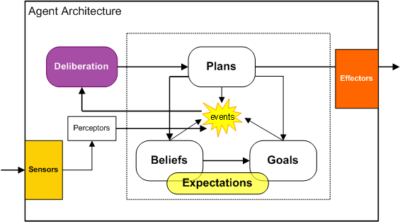
Fig. 1. Expectations can be built beginning from GOAL and BELIEF representations (i.e. Beliefs have a dynamic grade, Goals have a dynamic importance)

At the highest level of abstraction, Subjective Expected Utilities are used in mechanisms for Goal deliberation (subjective expected utility was defined in decision theoretical accounts as a function of the agent’s beliefs and desires; see Bratman et al. 88). Along the food foraging tasks, an internal buffer is updated and stores information about food “quality” (reward on goal achievement and food type) and “quantity” (frequencies, timestamps and location of the new food added in the belief base). Agent associates to each LOI a Subjective Expected Utility (SEU) given by Bel_{REW}, determined averaging rewards stored in a k-length memory for the last k delivered Foods, and P_{FLOI}, indicating the likelihood to discover foods near the LOI. Initially SEUs have default, normalized values. Meta-level reasoning evaluates best expected SEU and commit to the intention to look for food_x at the corresponding LOI_x. Once a food is located, agent reinforces P_{FLOI}. Otherwise, when a LOI is visited and no foods are located, P_{FLOI} is decreased. Agent meta-level-reasoning chooses and formulates the intentional attitude by comparing SEU (Bel_{REW} * P_{FLOI} ) and selecting for the specific plan toward best expected LOI according to a ε-greedy strategy.
What has to be noticed here is that SEU processing runs in “discrete time”, upon goal achievement or at action completion. Identifying with sensors a set of foods, agent adds them to the belief base and heads for the nearest one, observing topology, constraints and obstacle bounds. Deliberation from searching to pickup action is triggered when a food is located, from pickup to homing when a valuable is carried. Note that if a nearest food fj is located, a new intention inhibits and stops the current plan. Through a feedback signal, results of purposive action of depositing food are used to reinforce beliefs (and the associated expectation) on average reward. Further transition to searching is caused when the agent achieves the drop action.

Action selection strategies and Expectation of risk
Sometimes an agent has several alternative paths to reach a certain location. Means-end reasoning processes are introduced when agents choose a path between the available ones (means), to reach a target location (end). In the architecture, the RISK is a negative expectation (a threat): quantitatively risk is a variable inside the path beliefs that agents uses to move across the environment: it is augmented by unexpected negative events (e.g. fire or smoke threat) and decreased when the agent doesn’t discover dangerous objects. When negative registered events are located and are associable to a path in the belief base, the agent increases the corresponding risk value. Hence the agent chooses the path with the lower associated risk (which in turn is an expected threat).

Mental States
To model expectations and the effects of surprise at a “system level”, the agent includes a set of mental states relying on an “on-line” evaluation of expectations that are in the internal state. The general idea is that if an agent caches instantaneous k-length knowledge of the world, it could dynamically change its mental state, as a whole allowing reasoning to adapt to changes.
In most situations, such global knowledge is impractical or costly to collect but for sufficiently slow dynamics, agents can correctly estimate the state of the environment through repeated local observations. While agents move in environment they observe the world state (e.g. harmful entities, food objects) adding items to buffers. In particular, we use two distinct buffers to store positive and negative events.

In ISTC anticipatory agents, a PDA-like stack stores the expectation invalidations: these cached items have both an informative content (e.g. timestamp, Location, event type), and an evaluative content, because they are coupled with the positive (benefits) or negative (disadvantages) effects that the event entails. Starting from the series of local observations, stored in a short term memory, an agent controller periodically defines the mental state to adopt through a transition function.

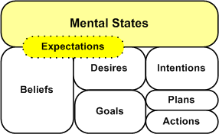
Fig. 2. ISTC layered model here evidences Expectations and Mental States.

Through a background process monitoring the cached items, the agent estimates the current environment state (i.e. infer β expectations) and consequently adapt its attitudes. On the basis of a theoretical model, ISTC distinguished between positive and negative surprise. For instance, having registered a close series of harmful events may signify that the agent is in a dangerous area and induce to pass to a cautious mental state (see Fig.3). Negative surprises are important either for learning, to be prudent, careful in harmful circumstances, either to reinforce “negative expectations”. ISTC designed cautiousness distinguishing two aspects: firstly the alert, to become more vigilant, to look ahead, to check better while and before moving (prudence against risks); secondly to be careful in doing dangerous actions, either augmenting the control or doing the action in another less risky way, using alternatives in repertoires.
Positive, exciting surprises are important for arousing the agent, for increasing the explorative activity and for searching for those ’good’ events. The lack of (negative) surprises reduces monitoring, increases speed: in the long run, the lack of surprises produces a special mood: boredom. The persistence of boredom can bring to curiosity, whose outcome is to shift from exploitation to exploration attitudes. The agent in this case can activate the epistemic goal of exploring and searching for unexpected event in order to enhance knowledge and update expectation model.

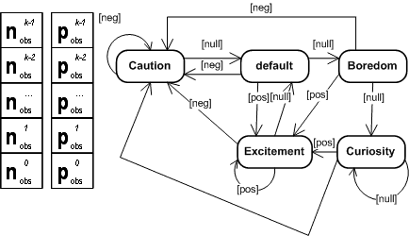
Fig. 3. ISTC Agent Mental States is build with a PDA

The use of a double stack for positive and negative events is taken to give a semantic value to each stack (i.e. positive and negative events are registered). Current mental state is recursively calculated with a transition function when the agent receives an input symbol from perceptual component and adds a new topic to its memory. Generally Mental State (MS) agent supervises (through their background processes) the buffers by balancing their registered contents: prevalence of negative events holds to cautious attitudes, while positive events hold to excitement. What the agent evaluates is a difference between the cached positive and negative events. Heuristic thresholds define the k-length time window used for passing from boredom to curiosity. The internal model has been described through a push down automaton (PDA) where a set of Mental States are designed for clustering attitudes in adaptive changes (for more details see Castelfranchi et al., 2006b, to appear).

IST “Emotivector”
Along the research to improve believability in synthetic characters, IST created an anticipatory module, the emotivector that can be used to control the low-level behaviour of a synthetic character implemented as a software agent, in such a way the character is perceived as more believable by the user.

The “emotivector” is an anticipatory mechanism that is coupled to an agent sensor, that:

- monitors the information flowing from the sensor to the processing module (percepts);
- from the history of observation, the emotivector anticipates the next sensor state. The prediction is inspired in both the two phase recirculation algorithm (Hinton and McClelland, 1988), a biologically plausible implementation of the backpropagation algorithm, and Kalman filtering (Kalman, 1960). A detailed description of the predictor can be found in (Martinho, 2006);
- interprets the mismatch between the predicted and the sensed value, by computing its attention grabbing potential and associating a qualitative sensation with the signal. This qualitative interpretation is based on theories from the psychology of attention and emotion. The details of the approach can be found in D5.1. However, and as described in (Martinho and Paiva, 2006), the affective model of sensations was extended since D5.1. The initial four sensation were extended to nine sensations;
- sends this interpretation along with the signal.

As such, when a signal from a sensor reaches the processing module of the agent, it carries recommendations such as: “you should seriously take this signal into consideration, as it is much better than we had expected” or “just forget this one, it is as bad as we predicted”. Of course, the agent processing module still has total control and has to decide whether to take this “relevance tag” into consideration or to ignore it altogether, according to its own control strategies.

Figure 4 shows the architecture supporting the described behaviour.

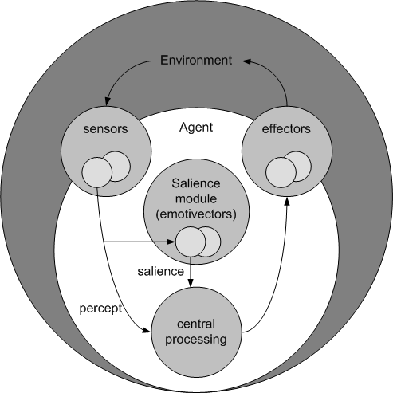
Fig. 4. IST Extended Agent Architecture

The emotivector (Martinho 05, 06) is a salience mechanism that is fed with values from a monitored signal and along with that signal makes a prediction for its next state and, accordingly, sends information for attentive processes. This information is based on the mismatch between the sensed value and the predicted value. On one side emotivector can just have a measure of surprise represented by an exogenous component that is proportional to the error made in prediction. On the other, emotivectors can also be informed with a value, called search value, which is desired to be achieved by the signal. So going towards this signal is considered a reward as going away from it considered a punishment (or a negative reward). The endogenous component measures the progress towards the desired value. Depending on the reward expected and reward received different sensations are elicited by the emotivector that gives an affective quality to the signal (See Table 1 below).

surprise (S) – no expectation on reward, i.e. no search value is given.
positive increase (S+)  It was received more reward than expected.  Related to excitement. | negative increase (S-)  It was received more punishment than expected.  Related to Fear or Anxiety.
positive reduction ($+)  It was received less reward than expected.  Related to Disappointment. | negative reduction ($-)  It was received less punishment than expected.  Related to Relief.
Table.1 Basic emotivector Sensations and elicited rewards

The salience of the signal associated the emotivector is then a combination of the exogenous and endogenous component of the emotivector.

To assess the viability of the approach, IST conducted an evaluation (Martinho and Paiva, 2006) with users playing a word puzzle game in tri-dimensional virtual world. In this game, the user must discover a word by observing how the synthetic character reacts to its actions in the world. With this evaluation, we showed that the users found the emotivector-controlled character to be more believable than other control algorithms used in the current generation of computer games.

Integration: Motivations and Objectives
In a preliminary phase of the integration, the aim was to combine low level functions into higher level ones. We pointed out that ISTC model is more deliberative: expectations are mainly designed at a top down of abstraction, and used to choose among goals in an expectation driven deliberation. ISTC adopts a goal driven architecture where reasoning process is governed by a BDI like engine. Research has been conducted considering that traditional BDI approaches lack on one side the prevision mechanisms and on the other the control of affective behaviour (see Castelfranchi et al. 2006b). In a comparison with other partner systems, ISTC refers mainly to some of the low level expectations that have not been designed yet, for instance those relative to the attentive processes and on the on line action controlling.
IST salience model works lower level, starting from prediction of perceived signals and from the analysis of the calculated ‘sensations’. At the core level of the IST architecture, the salience module relies on the capacity of the emotivectors to predict their next state. According to a bottom up choice, light support was given to higher deliberation mechanisms, agent motivations and purposive behaviour according to explicit expectation representation.

Given this, we have first imported in ISTC model a nice aspect of IST model (inspired by behaviourist psychologists): the fact that, given an expectation - which has not only a degree of certainty, but also a degree of utility/value - the mismatch with the actual outcome can be negative or positive. That is, the prediction can be partially wrong, but in two ways: because the outcome is worst than expected (less food, or lower quality of food); or because the outcome is better than expected (more or better food). This acquisition has provide to our model the possibility to deal not only with 'disappointment' and 'relief', but also with some sort of 'excitement' (the world is even better than expected) and of 'discomfort' (the world is even worst than expected), and with new dynamics of exploration.
Second we have decided to try a more ambitious 'integration', relative to the mechanism modeled by ISTC and IST and to the Agent's architecture: try to include IST salience modules in our BDI architectures for exploring Agents.

By using a model based on salience of remembered events (the IST emotivectors) ISTC powerful enriched lower mechanisms for prediction and statistical learning. ISTC model for subjective expected utility is easily associable to the IST salience model. On more detail, while ISTC SEU model defined a k-length memory buffer to estimate occurrences of signals and valuables in the environment, IST emotivector keeps a limited record of its associated signal history, and uses this information to compute a prediction for the next signal value to be read.
The built-in capabilities of IST emotivector to give behaviours from estimates of observable signals can be used as a black-box and partially substitute the original deliberation and intention-action schema.
Many interesting design solutions are investigated. A first analysis of the systems brought us to the following main considerationss:

Attention
A deeper integration was designed for attentive processes. Both IST and ISTC guess Attention and Emotion cannot be considered as independent processes. ISTC model of surprise points out a series of mental and behavioural changes, either on long and short term. On a lower level, ISTC model identifies, among the affective outcomes, reallocation of epistemic and attentive resources. In a functional fashion, surprising events elicit modulation of these values according to the positive or negative associated value. The adopted mental states clusters and re-allocate the resource configuration. For example in a case of a series of negative, dangerous, registered events, the agent shift to the cautious mental state and is able to focus on the source of the event. Appraisal processes are executed to obtain more information and update beliefs; concurrently the agent is able to improve the range of vision where sensors can retrieve data, the sensor sample rate and to modify its instant speed.
On the other hand, emotivectors are managed with a sensor salience: the percept is tagged with information and provides both its attention focus potential as well as its emotional potential.
As for the attention, IST embedded two interacting components to compute the emotivector salience: an exogenous component (based on the estimation error and reflecting the principle that the least expected event is more likely to attract the attention) and an endogenous component (modelling an estimation of a search window for the expected value). Both exogenous and endogenous salience defines the focusing capability through the relevance of the emotivector.

Expectation failure and Mismatches
ISTC modeled different kind of expectations and uses them at various level of reasoning. Getting feedback from a BDI-Like system is almost direct, since it structurally detects and processes success and failure of the execution of self-contained actions (at various level of granularity). Along the reasoning phases (deliberation, means-end reasoning, action-selection) ISTC agent executes activities/procedures from which collects result of failure/success. For instance for those expectations referring to Goals target-conditions, it is possible to feedback Goal success and failure matching results with expectations. Furthermore ISTC agents are built to detect the grade of achievement (in more-or-less / fuzzy domains).
In more detail, ISTC agents are able to manage (and detect mismatches) on two main kinds of expectations:

Expectation α: explicit expectations, consisting of predictions about the consequences of decision outcomes can be associated with alternative courses of actions. They are updated upon results of execution of plans and actions in a probabilistic fuzzy domain.
At a deliberative level, agent associates a Subjective Expected Utility (taken from a averaged k-length history buffer) to different intentions, and are able to evaluate mismatches upon a goal achievement, measuring discrepancies between the expected value and the real rewards obtained by the purposive action completion. At a discrete instant of time the meta-level reasoning is executed through an expectation driven deliberation that makes the best expected Goal to be adopted.
In means-end reasoning, at an action selection level, a salience model was managed to choose among alternative plans and actions the best expected one: those who have more success will dynamically inhibits to other ones because of their best expected value. Plans and actions results are further associated with the Goal Expectation (the end), whose expectation value further relies on the composition of the corresponding action (means).
Both goals and actions success / failure can be considered in terms of excitement / frustration, when the goal is achieved at more or less level than the agent expected.

Expectation β: dealing with those expectations with weak or implicit level of representation, due to lack of knowledge, absence of beliefs, uncertainty, ignorance. They hold to behavioural responses to unexpected events. Unexpected β signals elicit adaptation, reactiveness, backtracking, intention reconsideration, shift of motivations, opportunism and mainly hold to investment in resources. For instance long term and short term consequences of a negative surprise is to adopt the Cautious Mental State (see Mental States description in section 2).

IST works at a lower level of expectation and gives a more systematic model for salience and mismatches evaluation. They consider “Sensation” as a key aspect of the agent reasoning process. Sensations are triggered by sensorial stimuli, that can be either known/unknown either expected/unexpected. Sensations can be strictly related and matched to the presence or absence of rewards or punishments. The emotivector estimation is used to anticipate a reward or punishment which, when confronted to the actual value, triggers one of Hammond (1970) four basic sensations (fear, relief, hope and distress). Moreover, IST model attribute an intensity to each sensation, which value is the emotivector salience given by the endogenous component of the percept.

Redefined Scenario
The emotivector capability to estimate next states of monitored signals require some grade of regularities. In order to be anticipated, the monitored signals can’t be totally random generated. Light modifications to the original scenario environment are introduced to comply with the emotivector requirements. The new requirements have been designed to give emotivector components one more chance in their anticipatory capabilities. At the same time, refining the environment dynamics allowed a higher exploitation to the salience module without adversely affecting the quality of the core research.
At a quantitative level of description, the emotivector capability to estimate next states of monitored signals requires some grade of regularities. In order to be anticipated, the monitored values can’t be totally random generated. To deviate from these characteristics, the original world dynamic has been lightly modified: a linear progression in the generation of food value was given and a stronger characterization of the dangerous area was defined. We used the metaphor of “seasons”: a new food generation function was created and their values vary along the year in a cyclic way. Along years, foods valuables matures with a growing reward, or rot with a diminishing reward. This introduces more dynamics to the environment which in turn will enable the emotivectors predictive and anticipatory capabilities, not only the agent with the integrated architecture but also the original ISTC ones, with whom they will be compared.
Note that respect to the “Guard and Thief Scenario” described in the WP2.2 (section 3.2), here we only design the Thief agent, being the integrated architecture generalizable to the guards.

Design and Technical Reports

Architecture Analysis and Integration
For the purpose of integration the ISTC architecture was analysed to identify where the IST mechanisms could fit within the architecture and where they could improve it. In this section we outline this analysis and the integration of the mechanisms in the architecture and the influence this integration on the overall agent performance. Furthermore, using the emotivector mechanisms, we join different approaches on emotion/anticipation relation in the integrated architecture.

Because emotivector mechanism models the elicitation of feeling from the evaluation of expectations against the observed values, the focus of the analysis is put on where the expectations are being modelled within the ISTC architecture.
We identified expectations on different levels:

  - Expectations based on beliefs about the world;
  - Expectations associated with mental/emotional states;
  - Expectations associated with goals achievement;

Normal use for an emotivector would be to monitor a continuous variable that would change in regular intervals of time. An emotivector can predict the next value of such variable, as evaluating the mismatches between such expected value from the regular evolution of the variable and observed value from the world. This fits nicely in real world or physical properties, because these usually follow a continuous and regular progression and so next “normal” states can be easily predicted, but its use is not straightforward for isolated and non-continuous events like the ones occurring in the “Guards and Thieves” scenario because these usually don’t have an evident cause-effect relation or have a random progression.
However, for each of the levels with expectation it was studied which expectations existed and the possible emotivector-based systems modelling those expectations. The most promissing ones have been designed and implemented and they are described in the next sections.

Integration on Expectations about the world
We can identify the following three expectations among all the belief-driven expectations in the architecture proposed by ISTC:

- the expected probability of a kind food appearing at a certain “location of interest”;
- the expected score when dropping food at the repository or eating that food;
- the risk of taking a certain path instead of some other ones.

Emotivector can fit naturally in this kind of variables, like the food score, because they vary continuously and are locally linear in time as explained above. This way a prediction of the variable is easily found and the mismatch evaluation is straightforward. But for example a prediction that a certain object, like a fire, will be where the agent last saw it cannot be monitorized by a emotivector because the mismatch would be based on only one of two values (there or not there).
Giving strong dynamics to the environment the emotivector expectations would be unconfirmed and thus eliciting surprise. This is why some changes where made in the scenario’s environment regarding the score of foods as described in section 4. The other two variables in the expectations enumerated above are static in this environment so there is no need for the prediction of them and so there is no need for emotivector mechanisms there.

The integration designed aims at monitoring food score with the emotivector. Food score vary along time so the agent must predict the score that will receive for some food in order to better judge which food should it pick up for maximal reward and generally influence its behaviour.
We associated an emotivector for the score of each food type. The score for each specific kind of food in the environment evolves continuously and locally approximates a linear function of time. So, for the predictor, a simple extrapolation of the value based on the previously seen velocity (instant first derivative) and value is used. Because the real food score is sampled asynchronously the predictor is fed not only with the signal value but also with the time passed since the last sampling.
The search value of the emotivector is set do the maximum value because the agent desires to get the maximum score. Hence, exogenous component will just tell how wrong the expectation of score was and endogenous component will tell if the score is evolving to or from a desired one.
Figure 5 illustrates the prediction of value with the predictor used for the emotivector and the sensations generated at each time a new value is added to the emotivector. The predicted values from the SEU agent are also represented and we can see that this kind of prediction is not as adequate for this case as it is a more conservative prediction, i.e. it depends a lot more on the past than on the future states, and so its not so fit for this kind of signal that evolves continuously with time.

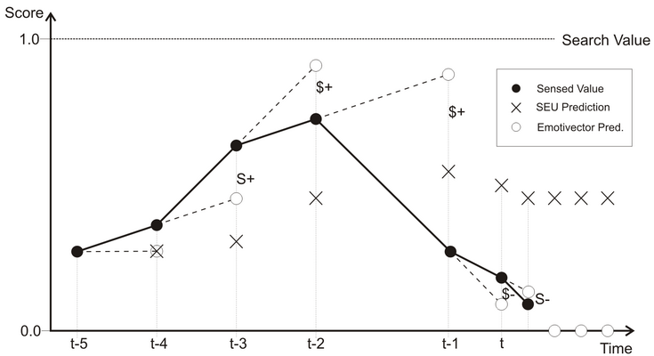
Fig. 5. Comparision between SEU and Emotivector predictions on the food score signal

Initial emotivector memory is set to zero to indicate ignorance of the agent on knowledge for the specific food score. Sampling of the food score value is taken every time the agent discovers a new food and when the agent picks the food. As reported above, these epistemic actions have a cost in terms of resources and computation but enable the agent to decrease uncertainty and make a more informed prediction (thus a better prediction).
The prediction of the next value of score for a food is also based on the prediction of the time the agent will take to arrive to that food. To get a prediction of the score, the time in which we want the prediction has to be indicated. To calculate it we simply make an average of the previous time intervals that the agent took to get to the food, being the most recent times more significant than old ones.

We had a first approach to this specific integration that turned out not to be a good option. All of the monitoring nevertheless it will be described here for the sake of documenting all the experimented alternatives. This first integration was based on the idea that when a prediction was not a good one or the score was worst or better than expected this should influence the mental state of the agent so it adapts its expectations and behaviour. Thus, when a mismatch occurred instead of just inserting a negative item on the negative queue of the cognitive map manager it is also added a weight of how negative the event is. Such weight is calculated based on the size of the error in the prediction and on the quality of feelings elicited by the mismatch on the emotivector. Hence, score evaluation could generate positive events too. The two components of the emotivector make sense to be used both for the weight of a negative or positive events because both express the convergence or not to expectations and desires of the agent about score. The sensations are generated when a food is seen or picked up and the agent perceives the score for it. Their integration can be expressed by the following table.

surprise (S) - used only when there is no search value. In this case the weight of the event is the value of the exogenous component multiplied by some parameter. And the item is a negative if the error is negative and positive if the error is positive.
positive increase (S+) - the exogenous value is multiplied by a positive increase factor (e.g. 1) and the event is positive. | negative increase (S-) - the exogenous value is multiplied by a negative increase factor (e.g. 1) and the event is negative.
positive reduction ($+) - the exogenous value is multiplied by a positive reduction factor (e.g. 0.5) and the event is positive. | negative reduction ($-) - the exogenous value is multiplied by a negative reduction factor (e.g. 0.5) and the event is negative.
Table.2 Sensations and their coping by the agent

In this way, we introduced a value of salience on the positive and negative events experienced by the agent and so have a new mechanism for adapting the given importance to each event.
All the other event items that go into the queues that cannot be weighted have a maximum weight. This could be redesigned so to attribute different weights for different events, even if they are static, and tune their value in a sensible and effective way.
Further, to switch between mental states the cognitive map manager instead of counting cached items on the short term memory to decide which mental state to adopt, should now, sums all the weights for each queue and compare the sums to decide which state to take. That is, rules for switching states are the same but instead of comparing the number of items, the weight of the queues are compared. Additionally, the decay of the queues instead of being on “time to die” given by a k-length time window, is now based on the decaying the events weights along time. By doing this, not only the older items will disappear from the queue, but also they will have lesser importance than newer ones, according to the principle of temporal locality.
The problem is that the mental states are influenced by local environment and influence behaviour for that same local. And so for example doesn’t make sense to be more cautious for hazards and so walk slowly if the agent made a bad prediction or the food score, which is something global to the environment, is getting bad.
We picked up from this first idea and saw that this evaluation of the food score by the emotivector made sense and could be helpful in evaluating SEU. This, because SEU of a kind of food is based on the prediction of score for it and it will influence the behaviour related to attaining food for its score, while emotivector gives extra information about this prediction.
The monitoring of food score is done in the same way as the first integration option using an emotivector for each food type with search value at the maximum and samples taken when food is seen or picked up just the consequences of its evaluation are different. Next is described the final integration.
For the final integration on food score each time the emotivector receives a value for the current food score; it compares it with the expected value and from the resulting mismatch elicits the according sensation (Table 1). For example, if is expected a score of 0.7 and is sensed 0.8, a S+ (positive increase) sensation is elicited associating, in this way, a good feeling about that particular food score.
As the search value is set to the maximum score, the sensations as well as the endogenous component can be considered as a reaction not just to reward on the signal but also as a reaction to the evolution of the signal. This way, for example, a S+ sensation signals to the agent that the food score is making a better progression than the one expected; a $+ sensation says that the monitored progression is getting worst than expected. The former case gives the agent a positive feeling about a particular food while the latter gives a negative feeling. Figure 6 shows the correspondence between sensations and valence of feeling, thus preference, associated with it.

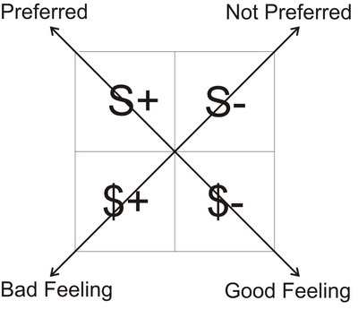
Fig.6. Computed “sensations” and associated feelings

The agents make use of these valenced feelings to give more or less preference toward a certain food type at the deliberative level (i.e. deciding towards which kind of food to look for). This is done by reinforcing the expectation for a food by a factor proportional to the distance between expected and sensed value in the case of a good feeling (and diminishing in the case of a bad feeling). Hence, emotivector give an affective bias for the SEU evaluation that way we can say this agent uses an affective subjective expected utility. This gives extra information for the SEU calculation, hence giving a better prediction, because it not only tells what it is the expected value but also if there is probability of it being better or worst. This anticipates the typical error between prediction and real value.

Integration Expectations Based on Mental States
Each ISTC mental state carries β expectations: when the agent is in any mental state it anticipates characteristics of local environment because this same environment made the agent be in the mental state. For instance, if the agent is cautious it is expecting the world around it to be especially threatening, thus anticipating negative events by adapting its behaviour and its resources to a dangerous area.
The appearance of this expected events is monitored by an internal process: an heuristic transition function decides if to keep the actual mental state, otherwise shift to another one (e.g. if the agent is cautious and few or no negative events occur it should realize it is safe now and go to a more relieved state). This is done already by the decay associated with each queue, i.e. if no negative events happen and/or positive ones do, eventually, the number of positives will surpass or be equal to the ones this way getting out of a cautious state.
A pay-off arises when the decay interval is too long: in these cases there’s the chance that the agent is wasting resources when it’s no longer necessary or generally not being efficient for the actual area because it is in an inadequate state of mind. On the contrary, if the decay is too short, there might be the risk that the agent underestimates threats, e.g. constantly shifting between mental states. This problem is now, in part diminished due to the first implementation done on the first integration on beliefs. In this implementation, events in the queue instead of disappearing after a time window their weight vanishes with time reducing they importance along time. Thus, recent events will be more meaningful than the ones happening before and so the mental state will be more along the require one for the local environment context.
A possible solution of the pay off problem is to have an emotivector monitoring the local frequency of events happening in each queue. In this case the auscultating emotivector expects the mental state assumptions about the world to hold: if they do not it would force a mental state change. For example, again in cautious mental state the agent should be expecting negatives events to happen frequently and positives infrequently: if the time interval between negative events hold to be bigger than it is expected and/or the positive events happen frequently, the agent changes to an excited mental state even if there can be more negative events than positives. Doing this the agent is anticipating the original ISTC transition function, either introducing a salience model and a prevision mechanism.
In this approach what is feed to the emotivector is not a continuous variable along time but one of the following alternatives that have to be tested:
- the time between events expected by the state
- the number of events happening in a regular interval of time
- the difference of positives and negatives happening and their time interval
Each mental state will have different sensations generating different results. The next table describes the behaviour for a general state. This description is abstracted for the kind of value input on the emotivector.

surprise (S) – not used, because there’s a search value.
positive increase (S+) - this sensation reinforces the mental state expectations. Hence the expectation should be strongly increased. | negative increase (S-) - this sensation diminishes the mental state expectations. Hence the expectation should be strongly broken.
positive reduction ($+) - this sensation goes along the mental state expectations. Hence the expectations are maintained. | negative reduction ($-) - this sensation does not go along the mental state expectations. Hence the expectations are lightly reduced.
Table.3 Sensations and their coping by the agents mental states
Endogenous and exogenous components should be used to measure quantitatively the expectations mismatch.

Expectations associated with goals
When a rational agent pursues a goal it is actively pursuing its satisfaction, so it is expecting the completion of all the plans that lead to the desired goal and it is also expecting that, globally, it is getting closer to the goal.
ISTC scenario defines a rational agent having a utility function associated with the goal: Subjective Expected Utility which measures how strong is the agent expectation to achieve the goal and it is updated by a feedback signal after goal completion (e.g. goal achievement reinforces the expectation and goal failure decreases the expectation). We point out that the agent should furthermore supervise the goal processing, for instance through some measure that reflects success in the middle way. This can be done through a emotivectors battery that allow to generate different kinds of feeling. These feelings can then be associated with the goal or plan and taken into account for action selection or intention reconsideration. This would make to have higher priority to those goals and plans that have given good outcomes over the ones that gave bad feelings.
As it is very difficult to find such measures of success before goal achievement (they are strongly context dependent), this integration has not yet been encoded, and it’s being left for future works. It has to be noticed that each goal progress has a different metric for being measured and eventually different measure functions that can’t be linearly compared to each other.

Discussion and Preliminary Experimental Results
The ISTC simulated world has made possible to involve IST components in a new class of problems: this different methodology, built upon recent affective computing results (Scheutz, 2004), has visibly opened the range of applicability for the single architectures.
This works extends two lines of research: ISTC work on anticipation through expectation and emotions effort, and IST work on salience model built upon emotivectors anticipatory capability. Having identified the main issue, we developed and realize a joint architecture integrating low-level anticipation and attention to a higher level of reasoning.

We tested with multiple trials for the foraging task, both with the SEU and the emotivector agents. Each agent adopts a Mental States controller to face with low level expectations and a case based controller for selecting safest navigation. Each trial had a fixed number of fires (8), a fixed number of food valuables and a fixed duration (3000 simulation clock ticks). Agent competition enhances the typical resource boundedness of the environment. We define expectation effectiveness (Re) as:
,
where R_{T} is the total amount of reward obtained during the single trial and N_{T} is the total number of food items appeared in the trial. Design, encoding and testing of the integrated system have showed clear contribution of emotivectors in performances: for the cases with static trends of food score the expectation effectiveness are comparable (Fig.7b), but the emotivectors agent outperforms SEU agent in the cases of sinusoidal progress of scores (Fig.7a).
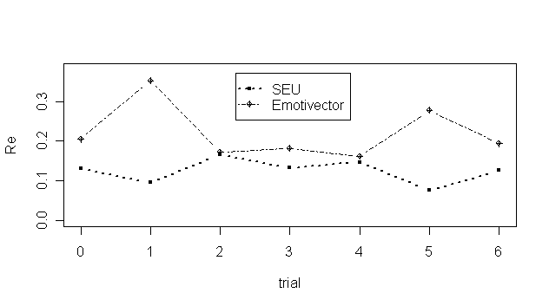
Figure 7a – Results with a dynamic food score environment
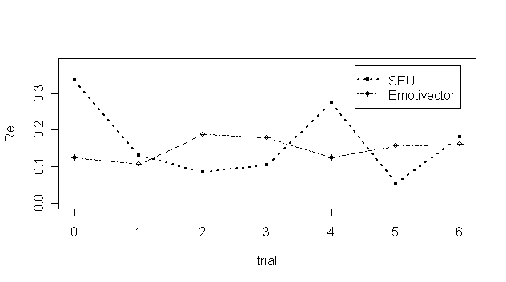
Figure 7b – Results with a static food score

Figure 5 illustrates the prediction given by the emotivector predictor and the sensations generated when a new value is sensed (and added to the emotivector memory). The predicted values from the SEU agent are also represented. We can see that the kind of prediction used on the SEU agents is not as adequate for the dynamic scores. SEU agent prediction, relying on a k-length history buffer, is a more conservative prediction: it depends more on the past than on the future states, and so it doesn’t fit for this kind of signal that evolves continuously with time (Fig.5). Also in the case of emotivector agents, uncertainty on the real world state causes ”dark zones” in expectation effectiveness and makes the agent take wrong decisions (and adopt wrong intentions) for example:
- when the sinusoidal food score function reverse its slope,
- when the emotivector internal knowledge model has not been updated

Outlooks and Roadmap for Future Works
This works extends and integrates two lines of research: firstly, work on anticipation through expectation and affective efforts, secondly, work on the salience model built upon emotivectors anticipatory capabilities. Expectations influence goal driven agents at different levels of reasoning, from goal deliberation, to means end/action selection processes. We defined different kind of mechanisms for deliberative agents with anticipatory capabilities relying on expectation processing.
Finally, we tested the different anticipatory strategies in two different environments, showing that agent design is strictly dependent on environment conditions and holds to world dependent design choices. The design model, given referring to the scenario requirements, can be extended in a wide range of applications.
Emotivector’s performance depends on the ability of its associated predictor to correctly predict the signal. So for each different variable type there should be a different predictor that best fits it.
Further mechanisms can be also designed in order to improve the expectation processing. We identified some deeper integration to be investigated. For instance, emotivectors and their salience module will be tested in order to introduce quantitative previsions about:
- Other agent’s actions and outcomes (i.e. guard agents).
- Risk evaluation.
- Attention.

Emotivector can be used also for modelling low level expectation associated with Mental States. In this case their salience model could be used for adaptive and attentive processes too. Furthermore the emotivectors outcomes (i.e. sensations) are further integrable with the mental states controller.
Goal expectation evaluation using emotivectors is described in section 5, but will be left for future and optional work because its design is very complex due to the goal context dependency of the measure of success of each goal.

The “guard” agent should also be improved to include anticipatory capabilities. We are planning to first improve and test the thief agents with the integrated architecture and then use it as a design structure for implementing the guard.

References
Carlos Martinho, Ana Paiva. Using Anticipation to Create Believable Behaviour, In proc. of the AAAI 2006 conference.
L. Hammond, Conditioned emotional state, In Physiological Correlates of Emotion. Academic Press, 1970.
Martinho, C.; Micelli, M.; Dias, J.; Paiva, A.; and Castelfranchi, C. 2005. Anticipation and emotion. Technical report, MindRACES Technical Report.
M. E. Bratman, D. J. Isreal, and M. E. Pollack. Plans and resource-bounded practical reasoning. Computational Intelligence, 4(4), 1988.
A.Rao and M. Georgeff. BDI Agents: from theory to practice. In V. Lesser, editor, Proceedings of the First International Conference on Multi-Agent Systems (ICMAS’95), pages 312–319, San Francisco, CA, USA, 1995. The MIT Press: Cambridge, MA, USA.
C. Castelfranchi. Mind as an anticipatory device: for a theory of expectations. In Proc. of the AAAI 05 Fall Symposium: From reactive to Anticipatory Cognitive Embodied Systems, 2005.
Castelfranchi, R. Falcone, and M. Piunti. Agents with anticipatory behaviors: To be cautious in a risky environment. In Proc. of European Conf. on Artificial Intelligence, Trento, Italy, 2006.
L. Braubach, A. Pokahr, and W. Lamersdorf. Jadex: A bdi agent system combinino middleware and reasoning. 2005.
C. Castelfranchi, R. Falcone, and M. Piunti. Surprise as shortcut for Anticipation: clustering Mental States in Reasoning. To appear.
M. Scheutz , How to Determine the Utility of Emotions, In Proceedings of AAAI Spring Symposium 2004.
G. Shafer and J. Pearl, Readings in Uncertain Reasoning. Palo Alto, CA: Morgan Kaufmann. (Eds.). 1990.
M. Piunti and J. Gonçalves, Integrating high and low level expectations in deliberative agents. (submitted to) Fourth European Workshop on Multi-Agent Systems Lisbon, Portugal.

UW-COGSCI and IDSIA: Joint Hierarchical Neural Network Development

UW and IDSIA are working on a hierarchical neural network implementation. The resulting system will be applied to the tracking tasks, proposed by LUCS and others in the MindRACES project. The aim is to build a hierarchical architecture that learns to analyze dynamic scenes identifying moving objects in the scene, distinguishing different moving objects as well as predicting the behavior of these objects. Generally, the architecture is intended to consist of interactive, hierarchical layers in which each layer either summarizes a lower-layer property disjunctively, consequently enlarging the receptive field representation of this property, or identifies a particular property conjunctively, consequently identifying a particular property (such as flow direction) in the particular receptive field (Riesenhuber & Poggio, 1999; Giese & Poggio, 2003; Poggio & Bizzi, 2004). To do so, the optical flow in the scene will be analyzed by recurrent neural network structures.
On the first layer, simple receptive fields will be distributed uniformly over the visual field. In a later stage, this uniform distribution might also be learned or distributed in a foveal-simulation distribution. The second layer is intended to analyze the activity flow of the first layer by multiplicative, sigma-pi like neurons (Hochreiter & Schmidhuber, 1997; Taylor, Hartley, & Taylor, 2005), which encode the predicted shift according to the current optical flow. This predictive activity flow will be down-projected to the first layer merging the predictive with the actual sensorial information with Kalman-filtering-based techniques.
The third and fourth layer then will be structured by clustering neurons and LSTM-like units, which cluster the visual flow with position-independent clusters (Weber, 2001; Weber & Wermter, 2003; Weber, Wermter, & Elshaw, 2006), and predict the behavior of those clusters. These layers should be able to predict the behavior of different moving objects (at first one object, such as a simulated ball). The prediction will be down-projected modifying the visual-flow input in the second-layer, based on Kalman-filtering principles (Kalman, 1960; Rao & Ballard, 1997, 1999; Haykin, 2002). The intention of the usage of LSTM (Hochreiter & Schmidhuber, 1997; Gers, Schmidhuber, & Cummins, 2000; P´erez-Ortiz, Gers, Eck, & Schmidhuber, 2003) units is to continue the simulation of the ball (or train, etc.) when the ball is temporarily hidden. To do so successfully, additional information may be provided to the LSTM layer indicating the presence of view-obstructing obstacles, reflecting obstacles, etc.
The network structure is intended to purely learn from experience. That is, the layers will be successively self-structured by an appropriately staged learning scheme that shapes the hierarchical layers successively. Thus, first optical flow predictions will be learned. Second, flow-information will be used as a teaching signal for the clustering-system on the third layer. Finally, the information on the third layer will be used to improve the predictions on the second and first layer, according to Kalman-filtering-based principles. To realize this network structure, we will work with predictively connected, hierarchical distributed neural layers that learn sequential patterns (Hawkins & George, 2006). As suggested in (Zimmermann, Grothmann, Schäfer, & Tietz, 2005), we will sparsely connect these network structures to balance memory requirements and focus the representational capabilities. In fact, we will use the principle of convolution networks with weight sharing (Lecun, Bottou, Bengio, & Haffner, 1998), which evolve cortical column structures that are replicated in multiple columns over the visual space. The structure inside the column(s) will be designed to be able to predict optical flow according to current top-down influence, or, similarly, observe optical flow and send the corresponding signals to the upper layer neurons. Thus, neural units will model activity of the layer below, given the past (Zimmermann et al., 2005). They should be able to do this autonomously (in the absence of further inputs), simply by the recurrent structure.
On top of this, we intend to learn how the internal state of a unit changes with its input, which comprises the activity stemming from (1) the receptive field below, (2) the self-recurrent activity prediction, and (3) the predictions stemming from the higher level region. These pieces of information will be combined with information theoretic methods estimating the reliability of each piece of information independently. Notions of surprise will be utilized to have the upper layers learn irregular behavior, or rather, behavioral changes of the predicted stimuli. That is, if the ball bounces against a wall or is hidden behind an obstacle, the upper layer will predict the information change in the lower layer. Otherwise, the upper layer does predict no change, that is, no modulation of the lower layer activity propagation. Thus, each neuron will not only compute its current activity propagation but also the confidence in its activity.
Learning will generally be done with restricted backpropagation techniques. As in LSTM, information will not be passed through gating units to prevent instabilities during learning. However, it will be important that the learning algorithm does not learn only single values but confidence values, in terms of probability densities, to be able to combine the available bits of information appropriately, dependent on their reliability estimates.

Preliminary Implementation
Currently, a preliminary implementation is available that learns to predict the optical flow in moving scenes. Once trained, the system is able to derive local movement information out of the scenes. This is simply done by watching first a camera moving over a scene. Weight sharing is used to learn a prediction of the activity of a point considering surrounding activity information. After training this system for a while, the mechanism is reversed, probabilistically deriving movement information out of the visual input alone.
The mechanism can deduce local movement information, basically detecting object-like movement through a scene. The next stage will be to add a successive layer structure that clusters the movement properties location independently deducing object structure information. Finally, an LSTM-like network will be applied on top in order to be able to represent object-permanence and typical object behavior such as bouncing properties, etc.
To achieve this successfully, we will first evaluate the classification capabilities of the clustering layer. That is, its capabilities of distinguishing different object shapes. Once such distinctions work successfully, we will then add another LSTM-like layer that can encode the movement properties as well as object-permanence, given temporally unavailable visual information.

References
Gers, F. A., Schmidhuber, J., & Cummins, F. (2000). Learning to forget: Continual prediction with LSTM. Neural Computation, 12 , 2451–2471.
Giese, M. A., & Poggio, T. (2003). Neural mechanisms for the recogniton of biological movements. Nature Reviews Neuroscience, 4 , 179–192.
Hawkins, F., & George, D. (2006). Hierarchical temporal memory: Concepts, theory, and terminology (Technical Report). Numenta Inc. http://www.numenta.com/Numenta HTM Concepts.pdf. 2
Haykin, S. (2002). Adaptive filter theory (4th edition ed.). Upper Saddle River, NJ: Prentice Hall.
Hochreiter, S., & Schmidhuber, J. (1997). Long short-term memory. Neural Computation, 9 , 1735–1780.
Kalman, R. E. (1960). A new approach to linear filtering and prediction problems. Transactions of the ASME-Journal of Basic Engineering, 82 (Series D), 35–45.
Lecun, Y., Bottou, L., Bengio, Y., & Haffner, P. (1998). Gradient-based learning applied to document recognition. Proceedings of the IEEE, 86 , 2278–2324.
P´erez-Ortiz, J. A., Gers, F. A., Eck, D., & Schmidhuber, J. (2003). Kalman filters improve LSTM network performance in problems unsolvable by traditional recurrent nets. Neural Networks, 16 , 241–250.
Poggio, T., & Bizzi, E. (2004). Generalization in vision and motor control. Nature, 431 , 768–774.
Rao, R. P. N., & Ballard, D. H. (1997). Dynamic model of visual recognition predicts neural response properties in the visual cortex. Neural Computation, 9 , 721–763.
Rao, R. P. N., & Ballard, D. H. (1999). Predictive coding in the visual cortex: a functional interpretation of some extra-classical receptive-field effects. Nature Neuroscience, 2 (1), 79–87.
Riesenhuber, M., & Poggio, T. (1999). Hierarchical models of object recognition in cortex. Nature Neuroscience, 2 , 1019–1025.
Taylor, J., Hartley, M., & Taylor, N. (2005). Attention as sigma-pi controlled ach-based feedback. Neural Networks, 2005. IJCNN ’05. Proceedings, 1 , 256– 261.
Weber, C. (2001). Self-organization of orientation maps, lateral connections, and dynamic receptive fields in the primary visual cortex. Artificial Neural Networks - ICANN 2001 : International Conference Vienna, Austria, August 21-25, 2001, Proceedings, 1147.
Weber, C., & Wermter, S. (2003). Object localisation using laterally connected ”what” and ”where” associator networks. Proceedings of the 2003 International Conference on Artificial Neural Networks, 813–820.
Weber, C., Wermter, S., & Elshaw, M. (2006). A hybrid generative and predictive model of the motor cortex. Neural Networks, 19 , 339–53.
Zimmermann, H.-G., Grothmann, R., Sch¨afer, A. M., & Tietz, C. (2005). Modeling large dynamical systems with dynamical consistent neural networks. In Haykin, Principe, Sejnowski, & McWhirter (Eds.), New Directions in Statistical Signal Processing: From Systems to Brain (pp. 1–42): MIT Press.

ISTC-CNR and NOZE: Theoretical Model Development and Design Solutions.

Since the beginning of MindRACES there has been a very close collaboration between ISTC-CNR and NOZE. Many theoretical models developed by ISTC-CNR in the last years have been developed, implemented and tested thanks to the technological infrastructures provided by NOZE. However, the collaboration does not consist only in technology transfer: among the two groups there is a continuous cross fertilization of ideas and solutions resulting in a progress of both the theoretical models and the design solutions.

The main result of this collaboration is the joint development of the software architecture AKIRA, in which many cognitive models have been implemented to be used in the “guards and thieves” MindRACES scenario, also resulting in a number of joint papers.

ISTC-CNR has a long tradition of theoretical and experimental cognitive modelling, resulting in a number of models ranging from individual to social cognition, which are developed, formalized and implemented at different levels. NOZE developed a general purpose, multithread architecture in which processes have a variable level of computational resources and can coordinate and exchange messages via a Blackboard. Both groups decided to use that architecture for implementing many of the ISTC-CNR models, thus during the MindRACES project it has been extended to implement the peculiar cognitive constructs described by the ISTC-CNR models such as beliefs and goals. The result is the software architecture AKIRA which is a suitable instrument for designing, implementing and testing cognitive models. AKIRA framework project (http://www.akira-project.org) started by NOZE in 2001 was born as a general purpose artificial intelligence toolkit able to support multi agent systems (MAS) desiderata together with a wide range of symbolic and subsymbolic functionalities (Fuzzy Logic, Fuzzy Cognitive Maps, Neural Networks, …). The cooperation with the ISTC-CNR in the
MindRACES Project started a new research path around that software. NOZE worked on the software following directions given by ISTC-CNR and by the Consortium trying to integrate into the framework, as much as possible, new cognitive design patterns and features considered important in the design of cognitive systems. Moreover during the first MindRACES project years NOZE understand the importance to have an integrated framework that can also be used as a testbed to compare different cognitive, and in particular anticipatory, mechanisms. It is a matter of fact that the wide range of different technologies used worldwide to produce simulations relying on the same mechanism can be, in a lot of cases, a strong limitation to a correct comparison between them. In that sense NOZE hope to end the MindRACES project with a mature framework able to support other institutions researches in cognitive areas. In this way, those institutions will benefits in a simple manner of our theoretical research result together with their implementations. In fact, in order to reach the latter goal, during MindRACES lifespan many computational aspects of AKIRA have been refined and instruments (such as libraries and algorithms) added; on the same time, the cognitive theories have been formalized and/or described in more procedural terms. In this sense the integration activity has resulted in a progress of both the models and the software architecture and the contribution of both groups was relevant.

Joint development of cognitive models
Currently four cognitive models have been implemented as a joint work of ISTC-CNR and NOZE:
1. An architecture for “practical reasoning” (Bratman et al., 1988) which is based on previous work by ISTC-CNR (Castelfranchi, 1996) about high-level cognition (such as goal orientedness, intentionality and planning): goals are based on reasons (supporting beliefs) and expectations formation and testing drive the reasoning. With respect to the originary model, the implementation formalizes the basic constructs (beliefs, goals, expectations) also showing how practical reasoning can be realized by a dynamic and resource-bounded process.

Bratman M., Israel D.J., Pollack, M. (1988) Plans and resource-bounded practical reasoning. Computational Intelligence, 4:349–355.
Castelfranchi, C. (1996) Reasons: belief support and goal dynamics. Mathware & Soft Computing, 3
Pezzulo G., Calvi G. (submitted). DiPRA: Distributed Practical Reasoning Architecture. Submitted to IJCAI 2007.

2. A schema based architecture suitable for implementing anticipatory capabilities in agent-environment sensor-motor interaction. This model incorporates the main theoretical ideas developed by ISTC-CNR on the multiple roles of anticipation for low-level cognition (such as control of action and action selection) (Castelfranchi, 2005), also comparing reactive and anticipatory strategies in situated, dynamic environments.

Castelfranchi, C. (2005) Mind as an Anticipatory Device: For a Theory of Expectations BVAI 2005, 2005, 258-276
Pezzulo G., Calvi G., Lalia D., Ognibene D. (2005). Fuzzy-based Schema Mechanisms in AKIRA. In IEEE Transactions, Proceedings of CIMCA2005.
Pezzulo G., Calvi G. (2006). A Schema Based Model of the Praying Mantis. Proceedings of SAB 2006

3. An architecture for visual search inspired by the “predictive coding” model (Rao and Ballard, 1999); we used the same schema based architecture previously described, enhanced with a hierarchical organization; visual search results from the cooperative action of many feature-specific schemas, prioritized according to their accuracy in generating predictions. This is also a demonstration that the cognitive capabilities provided by anticipation are not domain specific but the same architectural principles can be applied to action control as well as to perception and attention (for the sake of simplicity these domains are investigated in different work packages in MindRACES).

Pezzulo G., Calvi G. (2005). Dynamic Computation and Context Effects in the Hybrid Architecture AKIRA. In Anind Dey, Boicho Kokinov, David Leake, Roy Turner, Modeling and Using Context: 5th International and Interdisciplinary Conference CONTEXT 2005. Springer LNAI 3554.
Rao, R.P. & Ballard, D.H. (1999) Predictive coding in the visual cortex: a functional interpretation of some extra-classical receptive-field effects Nat Neurosci, 1999, 2, 79-87

4. A model of the cognitive development of perceptual and abstract categories based on the “perceptual symbol system” model (Barsalou, 1999); this work underlines the relevance of anticipatory representations in and for action, as described in (Conte and Castelfranchi, 1995).

Barsalou, L.W. (1999) Perceptual symbol systems. Behavioral and Brain Sciences, 1999, 22, 577-600
Conte, R. & Castelfranchi, C. Cognitive and Social Action University College London, 1995
Pezzulo, G., Baldassarre, G., Falcone, R., Castelfranchi, C. (2006) The Anticipatory Nature of Representations Proceedings of the 50th Anniversary Summit of Artificial Intelligence (ASAI50)
Pezzulo G., Calvi G. (2006). Toward a Perceptual Symbol System. Proceedings of EpiRob 2006

Finally, some other joint papers between ISTC-CNR and NOZE have been devoted to the analysis of the architecture AKIRA, describing how it can be exploited for cognitive modeling.

Pezzulo G., Calvi G. (2005). Distributed Representations and “Flexible” Modularity in Hybrid Architectures. Proceedings of COGSCI 2005.
Pezzulo G., Calvi G. and Falcone R. (2005). Integrating a MAS and a Pandemonium: the Open-Source Framework AKIRA. Proceedings of AAMAS 2005.

Part II - Methods and Software Transfer

OFAI and IDSIA: Using Long Short-Term Memory

Events, which are detected with the help of sensors, might have a delayed effect on the final outcome of a trial. One of the main problems to solve when dealing with such events is how to implement the necessary memory. Peter Tino, a former member of OFAI, developed the idea of “Prediction Fractal Machines” (Tino & Dorffner, 1998 and Parfitt et al., 1999), which are somehow related to Variable Length Markov Models (VLMM). The whole observed sequence of inputs is coded into a low-dimensional space, and similarity of sequences is expressed as a small distance in the new space. The space is partitioned into subsets and forecasts for a given sequence are constructed on the basis of all known sequences falling into the same subset. The algorithm has already been successfully applied, but although all observed inputs have an influence on the prediction, most weight is given to the most recent observations.
In comparison, the authors of the “Long Short-Term Memory” (LSTM) approach claim that their algorithm can learn to ignore longer passages of uninteresting inputs, assuming of course a sufficient number of training examples. To become acquainted with the philosophy, applicability and the performance of the “Long Short-Term Memory” approach, OFAI studied the available literature and tried to apply available LSTM programs. The list of articles (mostly available from the IDSIA web page) includes

- Hochreiter & Schmidhuber: Long Short-Term memory 1997
- Hochreiter & Schmidhuber: LSTM can solve hard long time lag problems, 2003
- Felix Gers: Long Short-Term Memory in recurrent networks, PHD thesis, 2001
- Felix Gers: Learning to forget: Continual prediction with LSTM, 2000b
- Gers 2000: Recurrent Nets that Time and Count
- Gers & Schmidhuber: LSTM recurrent networks learn simple context free and context sensitive languages.
- Bram Bakker: Reinforcement Learning with Long Short-Term Memory, NIPS, 2002
- Bram Bakker: Advantage(lambda) learning 2002
- Bakker, B., Linåker, F., and Schmidhuber, J. (2002). Reinforcement Learning in Partially Observable Mobile Robot Domains Using Unsupervised Event Extraction
- Bakker, B., Zhumatiy, V., Gruener, G., and Schmidhuber, J. (2003). A Robot that Reinforcement-Learns to Identify and Memorize Important Previous Observations.
- Bakker, B. (2004). The State of Mind: Reinforcement Learning with Recurrent Neural Networks. PhD thesis
- Mance E. Harmon & Leemon C. Baird III (1996). Multi-Player Residual Advantage Learning With General Function Approximation
- McCallum: Learning to Use Selective Attention and Short-Term memory in sequential tasks
- Peshkin & al. Learning Policies with external memory
- Linaker & Jacobson: Mobile Robot Learning of Delayed Response Tasks through event extraction
- Linaker & Niklasson 2000: Time series segmentation using an adaptive resource allocating vector quantization network based on change detection
These articles helped to understand the type of problems, which LSTM can solve in principle and the acquired insights were passed to the colleagues during an internal talk and once again during Martin Butz' (UW-COGSCI ) visit in Vienna.
With the intention to perform own experiments, we asked IDSIA, if a ready-to-run version of LSTM was available and were provided a C++ version applicable for one-dimensional time series or a more general Octave version. In the web we additionally found another older LSTM version developed by Sepp Hochreiter (Hochreiter, 2003) and the most advanced version from Felix Gers (Gers, 2001).
The tool for one-dimensional time series worked very well, but was of minor interest for OFAI, as the problems we would like to solve don’t belong to this class. We decided to foster integration and postpone further development of LSTM tools for our architecture to the third project year.

References
Parfitt S., Tino P., & Dorffner G. (1999). Graded grammaticality in prediction fractal machines. NIPS 1999: 52-58.
Tino P., & Doffner G. (1998). Recurrent neural networks with iterated function systems dynamics. In International ICSC/IFAC Symposium on Neural Computation (pp. 526-532). Canada/Switzerland: ISCSC Academic Press.

IDSIA and LUCS: From Bouncing Ball Simulation to Marble Run Game Scenario Environment

Scenario Modules
IDSIA is currently investigating LUCS' scenario environment for the bouncing ball simulation. After successful results the experiments will be expanded by real world data from the refrigerator game environment (marble run game) provided by LUCS as well. The purpose of these simulations is visual prediction, anticipating future movements and events based on smart interpolation and prediction techniques, even in the face of obstacles and occlusions. IDSIA investigates how the visual output from these simulations can be used by algorithms such as LSTM (Hochreiter and Schmidhuber, 1997) and Evolino (Schmidhuber et. al., 2006, Schmidhuber et. al., 2005, Wierstra et. al. 2005) to do next-step visual prediction. We are currently experimenting with hierarchical convolution architectures (LeCun et. al., 2005, LeCun et. al., 1998) in order to reduce the effective size of the parameter space. This seems to have beneficial effects in performance compared to simple "flat" architectures, as we have recently found in supervised visual memory-based learning on the Robertino. Furthermore, we are currently investigating how LUCS' framework of simulations can be applied to IDSIA's fovea-based approach (Schmidhuber and Huber, 1991).

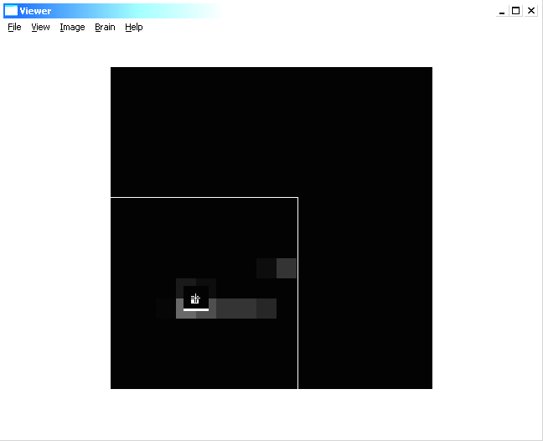
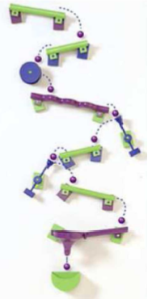
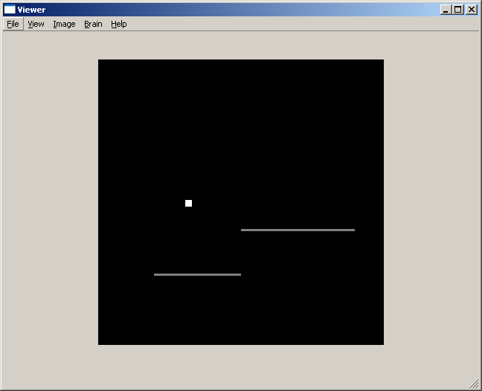
Fig. 1. A bouncing ball simulation frame in normal view (left), in a fovea view (middle) and a typical “Marble Run” game setup (right) is shown.

LUCS' IKAROS Framework
We have investigated LUCS' IKAROS framework, and so far deemed it hard to integrate with IDSIA software. Most of IDSIA's RNN-based algorithms are based on learning with both forward AND backward pass through time, whereas IKAROS only supports forward feeding (which is, of course, more biologically plausible). This is a major problem to be overcome, but we think it is possible to adapt our software such that it fits this framework, using truncated gradients and other such methods.

References
S. Hochreiter and J. Schmidhuber (1997). Long Short-Term Memory. Neural Computation, 9(8):1735-1780.
J. Schmidhuber, D. Wierstra, M. Gagliolo, F. Gomez (2006). Training Recurrent Networks by Evolino. Neural Computation, in press.
J. Schmidhuber, D. Wierstra, F. J. Gomez (2005). Evolino: Hybrid Neuroevolution / Optimal Linear Search for Sequence Learning. Proceedings of the 19th International Joint Conference on Artificial Intelligence (IJCAI), Edinburgh, p. 853-858.
D. Wierstra, F. Gomez, J. Schmidhuber (2005). Modeling systems with internal state using Evolino. In Proc. of the 2005 conference on genetic and evolutionary computation (GECCO), Washington, D. C., pp. 1795-1802, ACM Press, New York, NY, USA. PDF. Got a GECCO best paper award.
J. Schmidhuber, M. Gagliolo, D. Wierstra, F. Gomez (2005). Evolino for Recurrent Support Vector Machines. TR IDSIA-19-05, v2, 15 Dec 2005. Short version at ESANN 2006.
Y. LeCun, U. Muller, J. Ben, E. Cosatto, and B. Flepp (2005). Off-Road Obstacle Avoidance through End-to-End Learning, in Advances in Neural Information Processing Systems NIPS 2005.
Y. LeCun, L. Bottou, Y. Bengio, and P. Haffner (1998). Gradient-Based Learning Applied to Document Recognition, Proceedings of the IEEE, vol. 86, no. 11, pp. 2278-2324, Nov. 1998.
J. Schmidhuber and R. Huber (1991). Learning to generate artificial fovea trajectories for target detection. International Journal of Neural Systems, 2(1 & 2):135-141.

NOZE and LUCS: Technological integration between AKIRA and IKAROS

AKIRA (ISTC-CNR / NOZE) and IKAROS (LUCS) cognitive architectures are based on the same object oriented model and language (C++) and are very close in their code structure and organization. During the first two project years different kind of capabilities emerges from both these architectures demonstrating that they can be complementary used to build complex cognitive systems and simulations. Their integration, from a technical point of view, seemed to NOZE affordable and of interest for the project. In Fig 1 is possible to see the sketch of the communication infrastructure deployed.
Daemon
1

AKIRA

IKAROS
Daemon
2
Daemon
N
Module
1
Module
2
Module
N
AKIRA
Client Interface
AKIRA
Client Interface
AKIRA
Client Interface
AKIRA
Server
Interface
Fig 1: Integrating AKIRA and IKAROS

NOZE worked directly on IKAROS kernel to add new communication features at module level. Using the ACE (Adaptive Communication Environment) framework in combination with the AKIRA Client interface NOZE was able to integrate a powerful peer-to-peer communication mechanisms into IKAROS. Now both systems are able to send/receive between them data of any kind also delegating function calls (i.e. daemons in AKIRA, modules in IKAROS) to each others.

Part III - Comparisons

ISTC-CNR and UW-COGSCI: Comparing two models of goal oriented actions

ISTC-CNR and UW-COGSCI have analyzed and compared different teleonomic principles motivating their approaches to anticipatory control of actions.
From a theoretical perspective, the "ideomotor principle" and the "TOTE (test, operate, test, exit)" have been compared. From the analysis it results that the two principles are highly complementary and their functionalities can be integrated.
From an applicative perspective, three of the systems developed by ISTC-CNR and UW-COGSCI (an architecture for visual search, an architecture for reaching and anticipatory classifier systems) have been analyzed and compared; in particular, their aspects related to the "ideomotor principle" and the "TOTE" have been highlighted.
This activity resulted in the following joint paper:

Pezzulo G., Baldassarre G., Butz M. V., Castelfranchi C., Hoffmann J. (2006). An analysis of the ideomotor principle and TOTE. In Butz M. V., Sigaud O., Pezzulo G., Baldassarre G. (eds.), Proceeding of the ThirdWorkshop on Anticipatory Behaviour in Adaptive Learning Systems (ABiALS 2006). Rome, Istituto di Scienze e Tecnologie della Cognizione, Consiglio Nazionale delle Ricerche (ISTC-CNR).

This paper investigates the implications of the ideomotor principle (IMP) and the test operate test exit (TOTE) framework for adaptive behavior and action selection. It was shown that the frameworks are actually rather closely related as both stress the importance of goal-oriented action selection. Whereas goals are represented perceptually and are bidirectionally linked to
Associated actions in the IMP, TOTE emphasizes the interactive cycle of triggering Actions by desired goals while iteratively testing if such goals are achieved. Overall the two frameworks enlighten important aspects of the anticipatory nature of Goal driven systems. However, neither of them get concrete enough to pinpoint specific actual implementations.
The three implementations described in the paper represent important attempts to give possible answers to the problems left unresolved by them.

This joint theoretical investigation has also motivated a further joint activity between ISTC-CNR and UW-COGSCI, referred as "UW-COGSCI and ISTC-CNR: Developing and Comparing Robot Arm Models" in this deliverable.

OFAI and IST: Emotive driven Artificial Immune System

OFAI and IST are currently collaborating in finding sub-symbolic mechanisms that generate emotive states which influence the behaviour of the OFAI Artificial Immune System (AIS), enabling more complex anticipatory behaviours.
Intrinsic mechanisms enable the AIS to develop, whereas the imprecise but highly efficient recognition mechanisms and the capability of acquiring memories of past experiences are of particular interest, not only for suggesting a course of action in similar situations due to the episodic memory, but also in order to provide recommendations for actions in partially similar or even totally new situations. Planning and anticipatory behaviour emerges from the network, as a dynamic cascade of internal events. For example, a goal is represented as an antibody which is injected into the system. As in the immunological system, the network must respond to its antigen. At any point in time, the external environment will consist of multiple changing data items, representing goals, sensory information, maps and internal memory states; the resulting course of action results from a chain of antibodies firing, determined by the dynamically changing concentrations of antibodies. Thus, the network effectively records chains of events that can allow a desired goal to be achieved. This leads to the emergence of more complex behaviours and to anticipatory capabilities. However a more complex agent is able to show different behaviours in the same situation, depending on its internal state. In order to allow the emergence of more complex behaviours within the AIS, it is necessary to extend the system with sub-symbolic mechanisms that generate emotive states which influence the decision making process.
So far a preliminary solution which is then refined into more complex systematic approaches is suggested, with the goal of finalising in an Artificial Endocrine System. The first attempt is to use some kind of emotive “black-box”. This allows beginning with experiments and refining the system later. This “black-box” is a static, “pre-wired”, bootstrapped linking between environmental conditions and pre-defined emotions (e.g. hunger, fear, stress, love, etc.) without any learning. In the following, two ideas will be introduced, wherefrom one will be used to ultimately replace the “black-box” approach.
The first approach is a combination of the artificial immune system with an artificial endocrine system, maintaining homeostasis within the robot. The second approach is inspired by the general suppression framework (T-lymphocytes) from Ko et. al 2004, combining the OFAI AIS (B-Lymphocyte framework) with a T-Lymphocyte framework. In the following both of the ideas are described briefly.

Combining Endocrine and Artificial Immune System
The approach is inspired by Neal and Timmis in (Neal and Timmis 2002), suggesting an Artificial Endocrine System (AES), interacting with an Artificial Neural Network(ANN) to generate behaviour which could be classified as emotive.
The action of various endocrine products on the neural systems is accepted to be an important stimulus of a wide variety of behaviours. These range from behaviours such as flight and sexual activity to sleeping and eating. Neural and endocrine cells can express receptors for each other and hence influence each other.
Neal and Timmis’ mechanism is designed to maintain homeostasis within an organism. They suggest that homeostasis can be achieved via interactions between the nervous system, the endocrine system and the immune system. So far they limited their research to the combination of an ANN with an AES and suggested that combining it with an AIS is worth going after, but they did not attempt it until now.

Application / Experiments
The ANN/AES approach has been tested on a mobile robot in an office environment: Pioneer 2DX. The goal was to have an ANN network generating simple avoidance behaviour. Within the realisation, the alteration of the distance to which the robot would approach obstacles is subject to the hormonal control, e.g. in highly populated environments a more cautious behaviour is of advantage in order to avoid collisions.
ANN fully connected; no weight adaptation mechanism is employed at this stage;
Artificial neurons and artificial endocrine glands receive input from sensors. When a stimulus is encountered, the artificial endocrine gland excites or inhibits each synapse in the ANN via the hormone release mechanism. The activation level of the two output neurons is then used to drive the motors directly.
The experiments showed that the robot displayed rudimentary emotions such as “fear” and “distress”. Indeed it is surprising how people are very willing to project emotions onto a small autonomous robot which exhibits even very rudimentary displays of „distress“ and „fear“.

Combining B-Lymphocytes with T-Lymphocytes
Ko et al introduced a General Suppression Framework, modelling the suppression hypothesis of the immune discrimination theory, emphasizing the use of suppressor cells to eliminate counter productive behaviour.
The framework has been applied to two applications so far: the control of a modular robot, configured into a planar manipulator arm, generating emergent group behaviours by exhibiting aggressive or tolerant behaviour based on the environment change and for a control system, aiming to balance and navigate a self-balancing robot through obstacles.

Biological principle
The principle followed by the approach is inspired by the Immunosuppression.
T-lymphocyte receptors mature after binding to an antigen (which is being presented by an Antigen Presenting Cell – APC). At future contact with the antigen, it either attacks the antigen (aggressively) or tolerates it, depending on the presence of encouraging factors (the local environment in which the T-cell resides), which are inflammatory or anti-inflammatory substances. The influence of their presence is as follows:
- Inflammatory cytokine molecules (such as interferon-gamma) in the environment: aggressive behaviours of T-cells.
- Anti-inflammatory cytokines: aggressive behaviour is blocked.
After maturation, a T-lymphocyte emits humoral signals, converting other cells to join in the immune reaction. These humoral signals are not only influencing other T-Cells, but also the B-Lymphocytes, suppressing or stimulating them and thus influencing the immune-reaction of the B-Lymphocyte system.

Simulation and Implementation of the original approach
The goal was to exploit the T-cell suppression mechanism to control a modular robot configured in the form of a multi-link hyper-redundant planar manipulator arm in a decentralized way.
The robot arm consists of seven independent modules. The movement of the manipulator arm is indeed a reflection of the emergent behaviour of the seven autonomous modules. Each module can exhibit aggressive or tolerant behaviour; the decision is governed by two factors, the distance from the light source from the light sensor, and the torque status of the neighbouring modules in relation to the module’s own.

Summary
As mentioned in the introduction, the “black-box” approach for emotions will not use any learning and will later be replaced by more complex mechanisms, which have been briefly introduced above.
The T-Cell Framework coexists with the existing B-Cell Framework as part of the created AIS, overriding or encouraging the immune reactions (speaking on a biological level), hence introducing varying behaviour in varying situations.
In the ANN/AES inspired system, the AES coexists outside the AIS, as depicted in deliverable 6.1.
The third alternative would be to develop an AES/AIS/T-Cell Suppression system. All three systems receive direct input from the environment, interpreting it. The B-Cell part of the AIS would be coupled with the T-Lymphocyte apparatus, which is directly influenced by the AES (cytokine level), evaluating emotive states of the agent.
In the project meeting in April in Würzburg the partners discussed the planned joined work. The partners agreed on sketching the first ideas and scheduled another bilateral meeting.

References
Neal M. and Timmis J. (2002). Timidity: A Useful Mechanism for Robot Control? Informatica, 27(2):197-204, 2003.
Ko W.Y.A., Lau H.Y.K. and Lau T.L. (2004). A general suppression framework for distributed control, Proceedings of the 10th IEEE International Conference on Methods and Models in Automation and Robotics. Miedzyzdroje, Poland.
Dasgupta, D. (1999). Artificial immune systems and their applications. Springer Verlag.
Farmer, J., Packard, N., & Perelson, A. (1986). The immune system, adaptation and machine learning. Physica D., 22 , 187–204.
Garrett, S. M. (2005). How do we evaluate artificial immune systems? Evolutionary Computation, 13 , 145–178.
Glickman, M., Balthrop, J., & Forrest, S. (2005). A machine learning evaluation of an artificial immune system. Evolutionary Computation, 13 , 179–212.
Jerne, N. (1974). Towards a network theory of the immune system. Annals of Immunology, 125 , 373–389. 10

UW-COGSCI and OFAI: Comparing Artificial Immune Networks and Learning Classifier Systems

UW and OFAI are working on a comparison and integration of their two systems, the Artificial Immune System, and artificial immune networks in particular, and Learning Classifier Systems, and the XCS classifier system in particular.
Artificial immune systems (AISs) and learning classifier systems (LCSs) (Holland, 1976; Holland & Reitman, 1978) have been proposed more than two decades ago. Despite their originally rather different design motivation, both systems appear to have striking similarities. The aim of our comparison is to provide (1) a survey on AISs and LCSs pointing out major similarities and important differences, as well as (2) identifying potential integration of system mechanisms for the future development of both systems.
The motivation for AISs is the discovery of the immune system in animals and humans: Antibodies are able to detect and destroy foreign cells, so called antigens, by an intricate process of detection, attachment, marking, and final destruction of antigens. AISs mimic this process for computer security tasks, engineering applications, or network intrusion detection (Glickman, Balthrop, & Forrest, 2005; Dasgupta, 1999; Garrett, 2005). Artificial Immune Networks (AINs) were proposed by Jerne (Jerne, 1974; Farmer, Packard, & Perelson, 1986) as a subdivision of AISs, which specifies the interaction between antibodies as a network-like propagation of information.
The motivation for LCSs, on the other hand, comes from the cognitive side. Holland and Reitman (Holland, 1976; Holland & Reitman, 1978) called the first implementation of an LCS a cognitive system. They compared the different modules in an LCS (rule population, message list, etc...) to processes in the brain, such as motivations (internal reservoirs), working memory (message list) and long-term memory (classifier list). Despite the strong relation to cognition in LCSs, these systems have been successfully applied not only to behavioral or cognitive tasks (Wilson, 1994, 1995; Stolzmann, 1998; Butz & Hoffmann, 2002; Bull & Hurst, 2000) but also to classification and datamining tasks (Bernadó, Llorà, & Garrell, 2002; Dixon, Corne, & Oates, 2002; Bernadó-Mansilla & Garrell-Guiu, 2003; Butz, 2006a) as well as function approximation tasks (Wilson, 2000; Wilson, 2002, Lanzi, Loiacono, Wilson, & Goldberg, 2005; Butz, 2005).
Despite the different historic backgrounds and motivations of AISs and LCSs, it appears that both systems have many similarities. Most strikingly are the following: (1) both systems use rules (antibodies, classifiers) in their knowledge representation, (2) both systems evolve their knowledge representation by using evolutionary algorithms, (3) in both systems the rules compete against each other, (4) both systems learn iteratively interacting with the outside environment. Due to these similarities, it comes as a big surprise that the two algorithms have never been compared properly. Researchers in either field appear to be unaware of the other system—or, at least, they seem to be unaware of the strong similarities between the systems.
Currently UW and OFAI are working on a survey article comparing the two approaches identifying their differences and communalities. The aim is to combine the research efforts put into AINs and LCSs and consequently improve the systems making them more robust, flexible, and widely applicable. To do so, the robot realm is taken as an exemplar application domain. Over the next year, it is planned to use the insights gained from the comparison to develop an integrated system that is used in the AIBO and gripper tasks of the MindRACES project to evaluate the anticipatory capabilities of the evolving network structures.

References
Bernadó, E., Llorà, X., & Garrell, J. M. (2002). XCS and GALE: A comparative study of two learning classifier systems and six other learning algorithms on classification tasks. In Lanzi, P. L., Stolzmann, W., & Wilson, S. W. (Eds.), Advances in Learning Classifier Systems (LNAI 2321) (pp. 115–132). Berlin Heidelberg: Springer-Verlag.
Bernadó-Mansilla, E., & Garrell-Guiu, J. M. (2003). Accuracy-based learning classifier systems: Models, analysis, and applications to classification tasks. Evolutionary Computation, 11 , 209–238.
Bull, L., & Hurst, J. (2000). Self-adaptive mutation in ZCS controllers. Real-World Applications of Evolutionary Computing: Proceedings of the EvoNet Workshops - EvoRob 2000 , 339–346.
Butz, M. V. (2005). Kernel-based, ellipsoidal conditions in the real-valued XCS classifier system. GECCO 2005: Genetic and Evolutionary Computation Conference: Volume 2 , 1835–1842.
Butz, M. V., & Hoffmann, J. (2002). Anticipations control behavior: Animal behavior in an anticipatory learning classifier system. Adaptive Behavior , 10 , 75–96.
Dasgupta, D. (1999). Artificial immune systems and their applications. Springer Verlag.
Dixon, P. W., Corne, D. W., & Oates, M. J. (2002). A preliminary investigation of modified XCS as a generic data mining tool. In Lanzi, P. L., Stolzmann, W., & Wilson, S. W. (Eds.), Advances in learning classifier systems: Fourth international workshop, IWLCS 2001 (LNAI 2321) (pp. 133–150). Berlin Heidelberg: Springer-Verlag.
Farmer, J., Packard, N., & Perelson, A. (1986). The immune system, adaptation and machine learning. Physica D., 22 , 187–204.
Forrest, S., Perelson, A. S., Allen, L., & Kuri, R. C. (1994). Self-nonself discrimination in a computer.
Garrett, S. M. (2005). How do we evaluate artificial immune systems? Evolutionary Computation, 13 , 145–178.
Glickman, M., Balthrop, J., & Forrest, S. (2005). A machine learning evaluation of an artificial immune system. Evolutionary Computation, 13 , 179–212.
Holland, J. H. (1976). Adaptation. In Rosen, R., & Snell, F. (Eds.), Progress in theoretical biology, Volume 4 (pp. 263–293). New York: Academic Press.
Holland, J. H., & Reitman, J. S. (1978). Cognitive systems based on adaptive algorithms. In Waterman, D. A., & Hayes-Roth, F. (Eds.), Pattern directed inference systems (pp. 313–329). New York: Academic Press.
Jerne, N. (1974). Towards a network theory of the immune system. Annals of Immunology, 125 , 373–389. 10
Lanzi, P. L., Loiacono, D., Wilson, S. W., & Goldberg, D. E. (2005). Extending XCSF beyond linear approximation. GECCO 2005: Genetic and Evolutionary Computation Conference: Volume 2 , 1827–1834.
Wilson, S. W. (1994). ZCS: A zeroth level classifier system. Evolutionary Computation, 2 , 1–18.
Wilson, S. W. (1995). Classifier fitness based on accuracy. Evolutionary Computation, 3 (2), 149–175.
Wilson, S. W. (2000). Get real! XCS with continuous-valued inputs. In Lanzi, P. L., Stolzmann, W., & Wilson, S. W. (Eds.), Learning classifier systems: From foundations to applications (LNAI 1813) (pp. 209–219). Berlin Heidelberg: Springer-Verlag.
Wilson, S. W. (2002). Classifiers that approximate functions. Natural Computing, 1 , 211–234.

OFAI and ISTC-CNR: Comparing Artificial Immune Networks and Fuzzy-Based Schema Mechanisms

OFAI and ISTC-CNR are working on a comparison and integration of their two systems, the Artificial Immune System, and Artificial Immune Networks (Jerne, 1974) in particular, and the fuzzy-based Schema Mechanisms used in the AKIRA Architecture.
Like AIS and LCS, fuzzy based Schema Mechanisms and AIS also share a lot of common ground to start from in integrating both anticipatory mechanisms. As a basis we will use a WIKI (Wiki, 2006. Remy, 2002) knowledge base and collaboration system were both partners describe the basic ingredients, components and mechanisms of their according architectures. In the future this WIKI system should be published and provide a comprehensive compendium for the integrated architectures.

Issue | Schema Mechanism | Artificial Immune System
Framework | Schemas run as concurrent and asynchronous threads in a parallel platform and communicate via a blackboard. | The AIS is a network operating synchronously
Action Selection | Many schemas influence the behaviour, their influence level depends on their energy level (fire rate encodes relevance). All commands are fused (e.g. with fuzzy command fusion) by the controller. | The best matching B-cell controls action; selection is extended to similar B-cells but only for reinforcement (more concentration) and not action control. The matching mechanism is part of the affinity layer and distinguishes the AIS approach from other similar ones.
Structure of the “node” component | Schemas include a “detector” (for matching input), a controller (i.e. inverse model, for deciding the motor command) and a forward model (generating expectations) | A B-cell is a Condition (C) – Action (A) – Expectation (E) triplet.
Nature and use of “links” | Links between schemas are carriers of energy; they are learned (similar to hebbian learning) and involved in action selection | Links carries on topological information (i.e. they connect the Expectation of a B-cell and another B-cell. they are not explicitly represented in the AIS. They are used for building hierarchies, i.e. assembling macro actions
Inspiration | Modular systems | Vertebrate Immune system
Granularity | Schemas are quite coarse-grained, i.e. each schema is a complete motor program e.g. for following or tracking or avoiding | B-cells are more fine-grained, i.e. base level B-cells have only one action, each other layer is learned as a sequence of B-cells in the lower layer
Motives | Schemas satisfy directly a motive e.g. following, tracking, avoiding. They can be linked (and so reinforced) by related drives such as fear and hungriness | The AIS is initially filled in with basic instincts such as “desire to avoid collisions”, resulting in new and more complex behaviours to emerge.
Activation | Energy sets the priority of the thread is used for action selection. It depends on degree of matching, accuracy of expectation and contextual pressures by linked schemas. | Concentration is used for learning (it regulates some parameters of the evolutionary algorithm). It depends on the degree of matching (even of similar B-cells)
Hierarchies | It is possible to have hierarchies; schemas in the higher levels learn to anticipate and to control schemas in the lower levels (e.g. motor commands are only sent by the lower level). | Hierarchies are formed as sequences of B-cells in the lower level. Each level is independent. Higher levels provide more complex action sequences.
Monitoring | Schemas in the higher levels also monitor the activity of those in the lower level (and can e.g. stop control sequences) | Schemas in the higher levels also monitor the activity of those in the lower level (and can e.g. stop control sequences)
Role of expectations | Accuracy of expectations is used for action selection (schemas predicting well gain energy) | Expectations are used for the topology and for learning
Initialization | During initialization Schemas are specialized (by hand) for dealing with specific features (i.e. colours, size, shape) | During initialization B-cell are filled in with one random action
Learning | Two phases: in the first phase controllers and forward models of all the schemas are learned (e.g. fuzzy controllers or neural networks); in the second phase the links between the schemas are learned (similar to hebbian learning) | Evolutionary learning regulated by the B-cells concentration and the development of higher order structures in new emerging levels.
Learning Hierarchies | Hierarchies are designed by hand | Hierarchies evolve but their number is pre-determined
Tab. 1. Comparison matrix Artificial Immune Networks and fuzzy based Schema Mechanism Architecture

In a bilateral meeting in July the partners discussed the planned joint paper about the differences and similarities between the Artificial Immune Network (AIN) approach and the Schema Based Architecture approach. The partners sketched an evaluation matrix for the comparison of the two approaches (Table 1) and created a first draft of a AIN-SBA comparison, contrasting the main AIS architecture concepts to the corresponding parts in SBA, and elaborating the differences. One possible outcome of the integration should be the attempt to let Schema Mechanisms perform as one part of the cognitive function sets that control OFAI’s AIBO robot (in simulation and real life).

References
Dasgupta, D. (1999). Artificial immune systems and their applications. Springer Verlag.
Farmer, J., Packard, N., & Perelson, A. (1986). The immune system, adaptation and machine learning. Physica D., 22 , 187–204.
Garrett, S. M. (2005). How do we evaluate artificial immune systems? Evolutionary Computation, 13 , 145–178.
Glickman, M., Balthrop, J., & Forrest, S. (2005). A machine learning evaluation of an artificial immune system. Evolutionary Computation, 13 , 179–212.
Jerne, N. (1974). Towards a network theory of the immune system. Annals of Immunology, 125 , 373–389. 10
Remy, M. (2002). Wikipedia: The Free Encyclopedia. Online Information Review. v.26, n.6, p.434
Wiki (2003). http://en.wikipedia.org/wiki/Wiki

UW-COGSCI and ISTC-CNR: Comparing Robot Arm Models

Based on the ideomotor principle (IMP) (Herbart, 1825; James, 1890) and the test operate test exit (TOTE) principles (Miller et. al., 1960), ISTC-CNR and UW have developed two robot arm models. Both models realize anticipatory principles in their own way.
The ISTC-CNR system is mainly formed by two components: a postural controller and a reinforcement-learning component (“RL component” for short). In a first learning phase, the postural controller learns how to execute sensorimotor primitives that lead the arm to assume certain postures in space. In order to do so, while the system performs random actions (similarly to “motor babbling” in infants, Melthoff, & Moore, 1997), the postural controller learns to categorize the perceived arm’s angles in a 2D self-organizing map (Kohonen, 2001). At the same time a two-layer network is trained, by a supervised learning algorithm (Widrow, & Hoff 1960), to associate the arm’s angles (desired output pattern) with the map’s representation of them (input pattern). This process allows the system: (a) to develop a population-code representation of sensorimotor primitives within the self-organizing map, encoded in terms of the corresponding “goals” (i.e. postures); (b) to develop weights between the map and the desired arm’s angles that allow selecting sensorimotor primitives by suitably activating the corresponding goals within the map.
While the former controller focuses on the selection of goal to execute sensory motor primitives (which are generated by a servoing mechanism), UW’s controller focuses on learning an actual servoing mechanism by means of IMP. The architectures is called the sensory-motor, unsupervised, redundancy-resolving control architecture (SURE_REACH). The architecture again uses motor babbling to experience sensory-motor contingencies, which are stored in an inverse model structure. A motor controller is then able to execute goal-oriented behaviour using its learned inverse model, given particular goals. SURE_REACH is able to solve the redundancy problem of redundant arm constellations: Instead of learning one solution for each possible goal position, SURE_REACH redundantly but compactly stores all possible solutions and chooses the closest, currently available solution. Closest is hereby defined by the learned inverse model itself. Moreover, SURE_REACH is able to flexibly incorporate additional task constraints exhibiting, for example, effective obstacle avoidance behaviour.
UW and ISTC-CNR plan to write a comparison of the two approaches and combine them into one goal-oriented architecture, which exhibits flexible learning of sequential goal-oriented reaching tasks with additional challenges, such as obstacle avoidance or tube-constrained reaching. Hereby, the behaviour will be guided by goals generated by the reinforcement learning system (actor-critic) from the ISTC-CNR architecture. Goal pursuance then will be controlled by SURE_REACH. In this way, we hope to be able to show effective goal-oriented behaviour – where the behaviour will be context-dependent effectively avoiding obstacles or choosing trajectories or end-point arm constellations, which are maximally suitable.

References
J. A. Adams (1971). A closed-loop theory of motor learning. Journal of Motor Behavior, 3:111–149.
J. Herbart (1825). Psychologie als Wissenschaft neu gegründet auf Erfahrung, Metaphysik und Mathematik. Zweiter, analytischer Teil. August Wilhem Unzer, Koenigsberg, Germany.
W. James (1890). The Principles of Psychology. Dover Publications, New York.
T. Kohonen (2001). Self-Organizing Maps. Springer-Verlag, Berlin Heidelberg, New York, 3rd edition.
A. N. Meltzoff and M. K. Moore (1997). Explaining facial imitation: A theoretical model. Early Development and Parenting, 6:179–192.
G. A. Miller, E. Galanter, and K. H. Pribram (1960). Plans and the Structure of Behavior. New York.
D. Ognibene, A. Rega, and G. Baldassarre (2006). A model of reaching integrating continuous reinforcement learning, accumulator models, and direct inverse modelling. In S. Nolfi, G. Baldassarre, D. Marocco, D. Parisi, R. Calabretta, J. Hallam, and J.-A. Meyer, editors, From Animals to Animats 9: Proceedings of the Ninth International Conference on the Simulation of Adaptive Behavior (SAB-2006).
B. Widrow and M. Hoff (1960). Adaptive switching circuits. In IRE WESCON Convention Record, Part 4, pp 96–104.

For more details see Jadex project at http://sourceforge.net/projects/jadex/
This memory-based adaptation mechanism controlled by storing local observations in a rolling memory window, was originally used for dynamic task allocation and action selection in real robots.
If the memory has length k, then the agent that is making decisions about future actions relying on the past k states. The process can be represented as a generalized Markov process of order k.

